

Gesture Recognition Using Inductive Array Sensor Array

By

Aritra Apon

Dave Persaud

Patrick Mazza

Kevin Gay

Yousef Ahmed

Faculty Advisor: Dr. Reza Amineh

Capstone project proposal submitted in partial fulfillment of

the requirement of the Degree of Bachelors of Science

in the Department of Electrical and Computer Engineering

in the School of Engineering and Computing Sciences

of New York Institute of Technology

Spring 2022

**Abstract** 4

**1 Executive Summary** 5

**2 Opportunity** 6

**3 Plan of Action** 7

**3.1 Project Components** 10

**3.2 Hardware/Software Requirements** 12

**3.3 Standards** 23

**4 Commercialization** 24

**5 Limitations and Further Development** 26

**5.1 Impact** 34

**5.2 Prior Art** 35

**6 Project Management Plan**35

**6.1 Research Plan** 35

**6.1.1 Inductive Coils - Aritra & Kevin** 36

**6.1.2 DAB & MUX - Aritra & Kevin & Patrick** 36

**6.1.3 Arduino and MATLAB - Patrick & Yousef & Dave** 36

**6.2 Team and Collaboration**37

**6.2.1 Profile Team Leader Aritra Apon** 37

**6.2.2 Profile Team Member Dave Persaud** 37

**6.2.3 Profile Team Member Patrick Mazza**38

**6.2.4 Profile Team Member Kevin Gay** 38

**6.2.5 Profile Team Member Yousef Ahmed** 38

**6.3 Timeline & Milestones**  34

**7 Resources and Budget**39

**References** 41

**Appendix** 43

## Abstract

Gesture recognition is the act of recognizing and interpreting gestures made by humans, and through computer processes and mathematical algorithms produce an outcome to that gesture. Gesture recognition applications range from the use of controlling external technology, such as cars, industrial tools, medical devices, etc. Capacitive sensing has been used for gesture recognition, however when applying this technology to sensing gestures at a proximity, inductive sensing fits the requirements. Using electromagnetic (EM) wave interactions of eddy currents with inductive sensors and conductive targets such as a human finger, a frequency reading can be obtained. Using a collection of frequencies, four distinct gesture recognition can be implemented producing four unique outputs to move an external object.

## 

## 

## 

## 

## 

## 

## 1 Executive Summary

Gesture recognition technology currently is vision based which means that it mainly utilizes camera and motion sensors to recognize movement in real time. Gesture recognition technology is being implemented in many common appliances such as smartphones. This implementation can be taken further to aid those with disabilities. Studies have predicted that the gesture recognition and touchless sensing market is projected to reach 37.6 billion USD in 2026 from the current 13.6 billion USD in 2021. Along with that, the global assistive robotics market is predicted to grow to 25.16 billion USD. Due to the rise of COVID-19 and advancements in Artificial Technology (AI) , increasing amounts of investment and research are going into this field. Using inductive array sensors eliminates the need for visual sensors and the motion sensor will be replaced with applications of eddy currents and change in the magnetic to recognize gestures [3].

## 

## 

## 

## 

## 

## 2 Opportunity

The problem that this project is trying to solve is to successfully create a device to recognize gestures from a human hand by inductive sensing. The impacts of this technology could be seen on an enormous scale. The application of sensing hand gestures without the use of computer vision or a 3rd party device such as an inductive glove has the potential to be implemented into many different technologies and walks of life. Inductive sensing is a new technology and can be the new normal when dealing with devices by gestures. When it comes to wheelchairs, the only inductive sensing that is currently in the beginning stages of development are inductive tongue controlled powered wheelchairs. Our device will have an easy interface created and used with simple hand movements. The interface between the inductive coils and the wheelchair will be extremely user friendly and easy to use. The user will feel more free flowing then with any other technology that controls a wheelchair i.e. joystick. The aesthetic of controlling a technology with only gestures is pleasing and looks like the future which is never lost on consumers.

## 

## 

## 

## 3 Plan of Action

The proposed device will specialize in inductive gesture recognition. An array of commercial inductive coils will be used to sense the inductance of any conductive material near its presence. Through the inductance of the human finger, the coils will detect an inductance from a few inches and create a shift in the resonant frequency, which will allow different gestures made by the hand to be recognized. These coils are cheaply manufactured and are capable of using frequencies ranging from 10 kHz to 10 MHz. These inductive coils will be connected to a commercial data acquisitions board which will convert the analog measured data to digital data. This data will then be sent to a machine learning algorithm which will be trained to detect and predict certain gestures based on data acquired and associate certain commands with that gesture [5].

This proposed innovation will help deal with individuals with disabilities, specifically individuals using an electric wheelchair. The array of inductive coils will be placed on either the left or right hand side of the wheelchairs arm and using certain gestures the system will initiate certain commands that will cause an action in the wheelchair. This idea takes away the aspect of computer vision present in gesture recognition and introduces the new concept of gesture recognition through inductive sensing.

The main concept that is being implemented for gesture recognition is resonance frequency:

$f_{r}=\frac{1}{2π\sqrt{LC}}$ (1)

From equation (1), $f_{r}$ stands for the resonant frequency, C stands for the capacitance of the coils, and L stands for the inductance of the coils. The inductive coils act in parallel with a capacitor to create an LC tank circuit. When a coil is in proximity with a conductive material, the magnetic field of the coil affects the magnetic field of the conductive material. The magnetic field induced by the conductive material will cause a change in the inductive value. The interaction between the coils field and the conductive materials field causes the presence of eddy currents from the conductive material. These eddy currents from the conductive material is basically an AC current that is resistive or acts in opposition to the AC current in the coils. The eddy currents once interacting with the coils magnetic field will cause a drop in the inductive value of the coil. This will cause an increase in resonant frequency. The LDC1614 is able to measure the shift in resonant frequency of the LC circuit and convert the analog data to digital data.

The next step in our design is to have the microcontroller extract the digital data from the LDC1614 and send this data to the MATLAB environment for construction of a dataset for machine learning training. The data we collect from the arduino into MATLAB is the “raw data”; this is what will be used for gesture classification.

In order to house the hardware components safely and prevent users from excessively touching the wire configuration, DAB, the LDC 1614, and Arduino will be placed in a case which has the coils on a top plate exposed for easy inductive sensing and reading. A picture of this case can be seen below in figure 1 and figure 2. The casing below provides a solid foundation for the system and holds all components intact, although more improvements can be implemented.

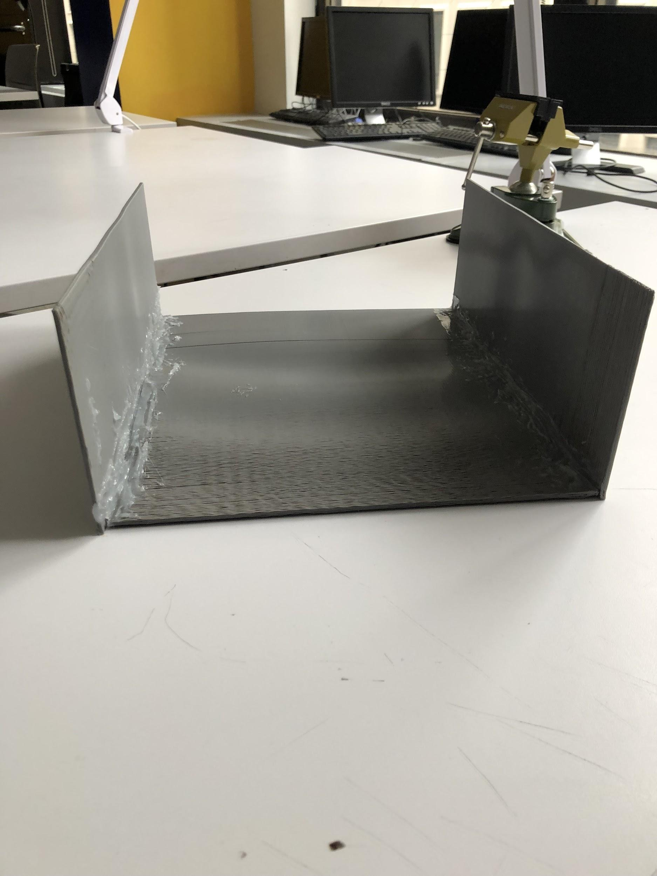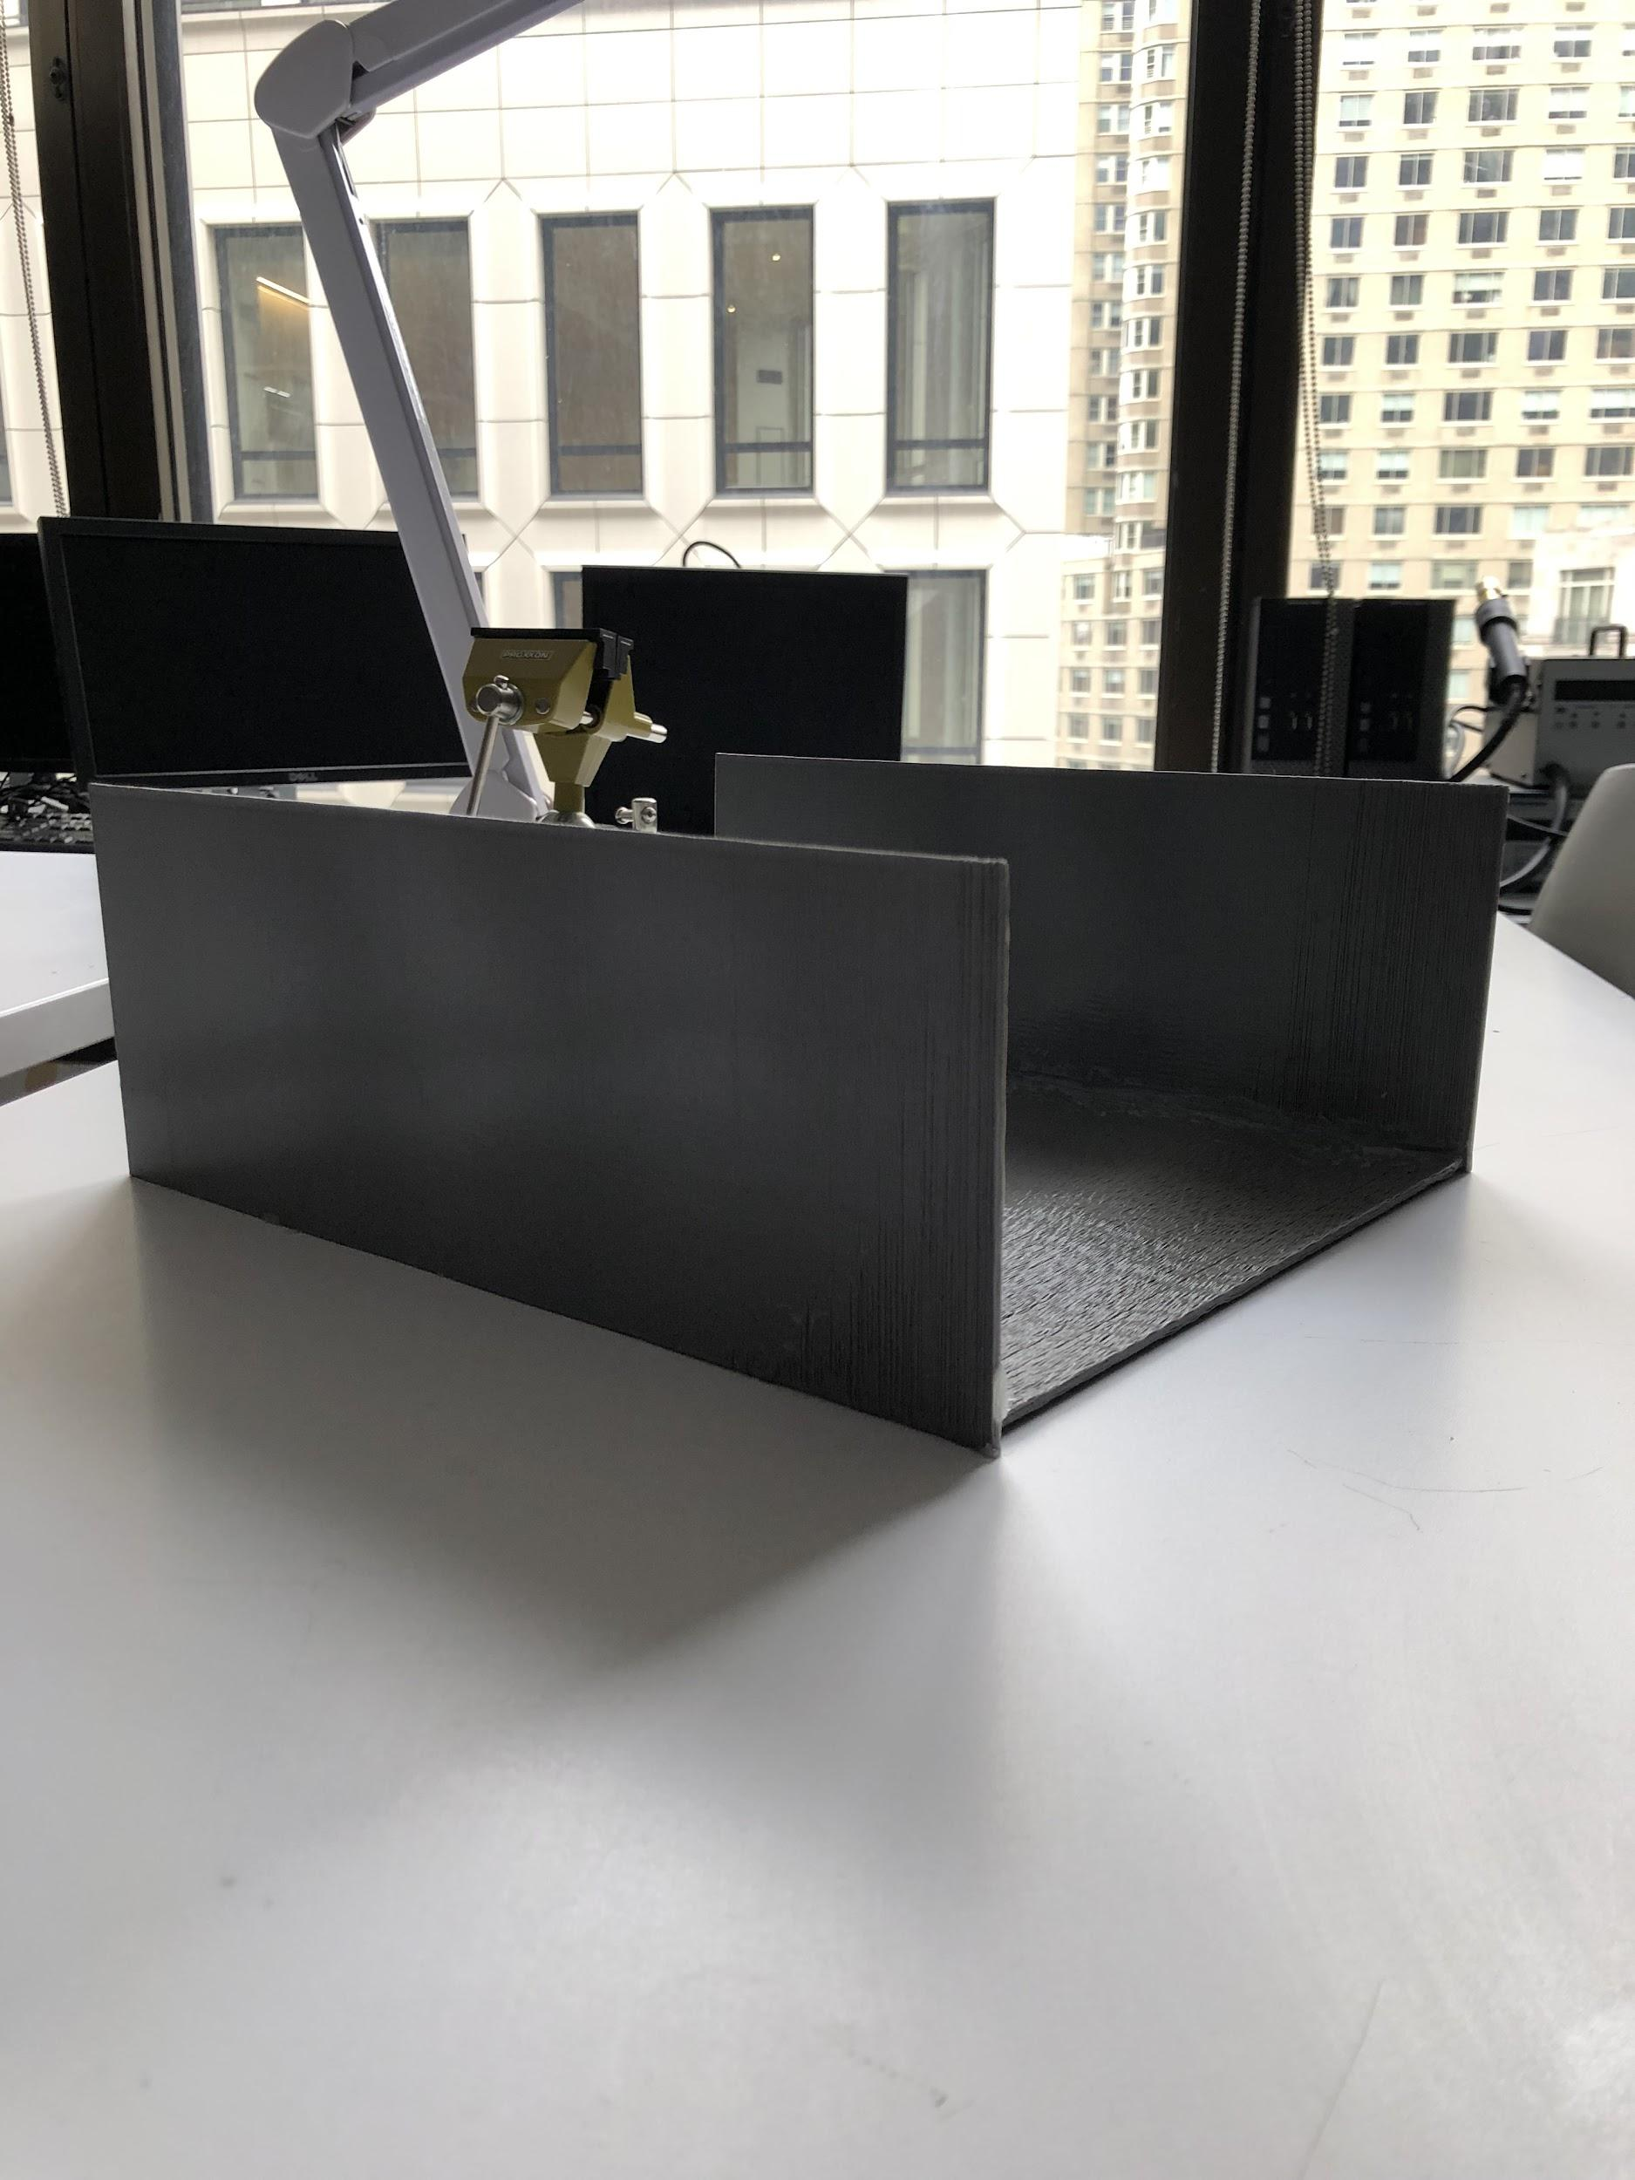

Figure 1: 3D printed case with a removable plexiglass door.

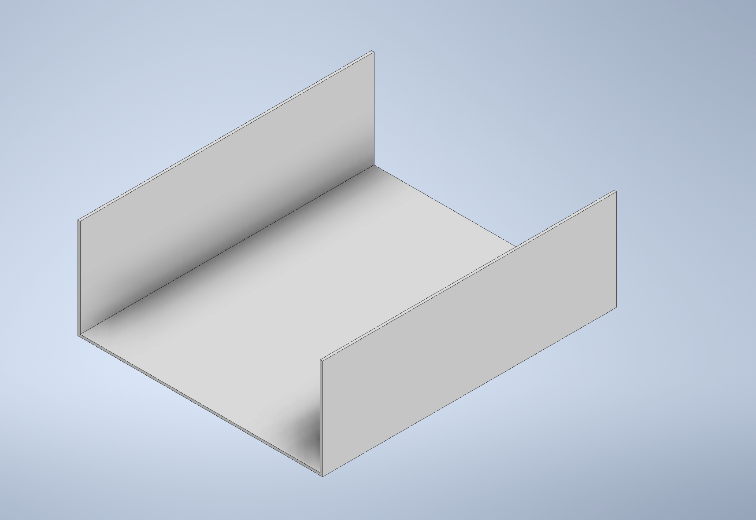

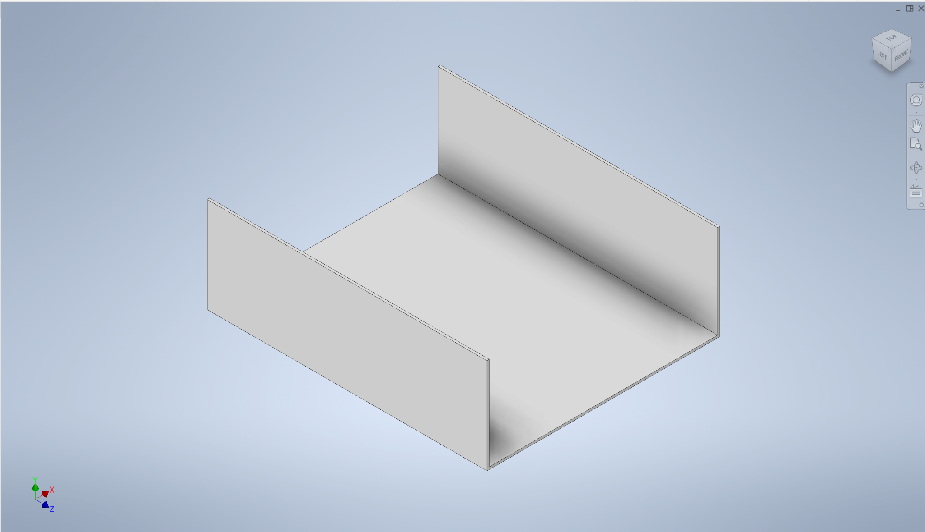

Figure 2: The design for the 3D printing case that our system will reside in.

## 3.1 Project Components

The overall system has one feedback loop being implemented. The block diagram, as shown in figure 3, has an input gesture being read by an array of inductive coils while the MUX switches between the different coils in approximately one second. Then the LDC1614 converts the analog data to digital, sending all the data to the microcontroller for processing. The microcontroller then sends all processed data to the machine learning model for classification which will lead to a command output based on the predicted input gesture. The feedback loop for the system block diagram consists of the recognition of a new gesture. The system continuously reads for an input gesture and continuously outputs a command based on the input. When the system recognizes a change in gesture, it continuously reads the changed gesture and outputs a new command associated with the changed gesture.

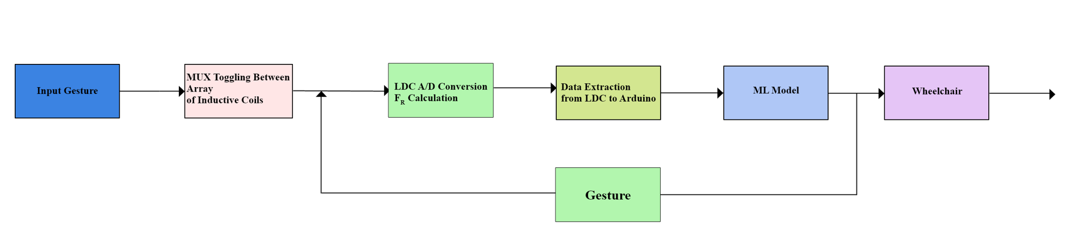

Figure 3: Block diagram of the first feedback loop

## 3.2 Hardware/Software Requirements

# The LDCCOILEVM Reference Coil Board Evaluation Module from Texas Instrument contains the inductive sensors that act as the inductor in the LC circuit. These sensors will be used to measure the shift in inductance which will indicate which gesture is being sensed on the coils. For this project all coils used in the system were the same shape, size and turns. Figure 4, shows the array of inductive coils found in the module that is used in the project.

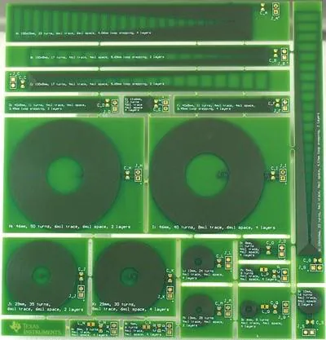

Figure 4: LDCCOILEVM Reference Coil Board Evaluation Module

The LDC1614 EVM from Texas Instruments is the data acquisition board that will measure the change in inductance for the LC circuit. The LDC converts the analog data from the coils to digital data. The LDC1614 contains four channels that can connect LDC coils to these channels. It has I2C pins that serve to connect to an Arduino, with a port to connect to the computer. Figure 5 shows the LDC1614 that is used.

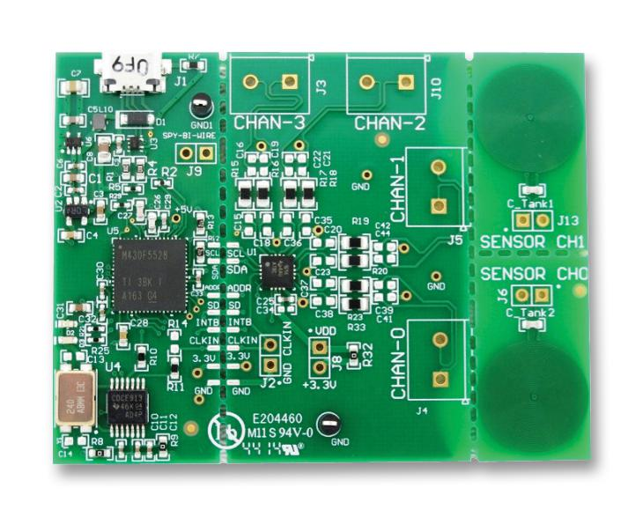

Figure 5: LDC1614 EVM data acquisition board

The microcontroller being used is the Arduino UNO R3, shown in figure 6, which operates at 5V. It will be used to extract the digital data from the LDC1614. The arduino will also send the data (changes in resonant frequencies, inductance, and raw data) to the machine learning algorithm in a format the machine learning computer algorithm can make use of.

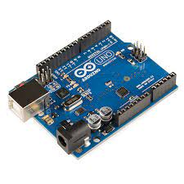

Figure 6: Arduino Uno R3 Microprocessor

Due to the use of an array of inductive coils the use of a multiplexer (MUX) is needed to switch/toggle between the input different coils and send multiple signals to a singular output to the LDC channel. The multiplexer used in this project is the CD74HCT4351E from Texas Instruments as seen in figure 7. It is a 8:1 encoder/decoder analog multiplexer that operates on 5V. This MUX was used to do it being able to handle the high frequencies of the coils and LDC, along with its capability to accept eight inputs. The way the inputs are selected is through programming the MUX using HIGH and LOW (1 and 0) binary combinations using the E1, E2, S2, S1, and S0 pins. Figure 8 shows a schematic of the MUX with the current coils that are installed. Currently there are four coils installed due to the previous arrangement of coil design.

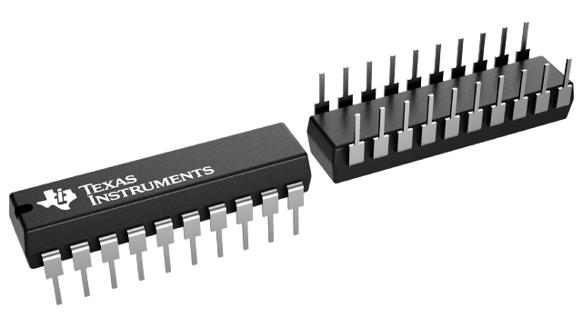

Figure 7: CD74HCT4351E Multiplexer

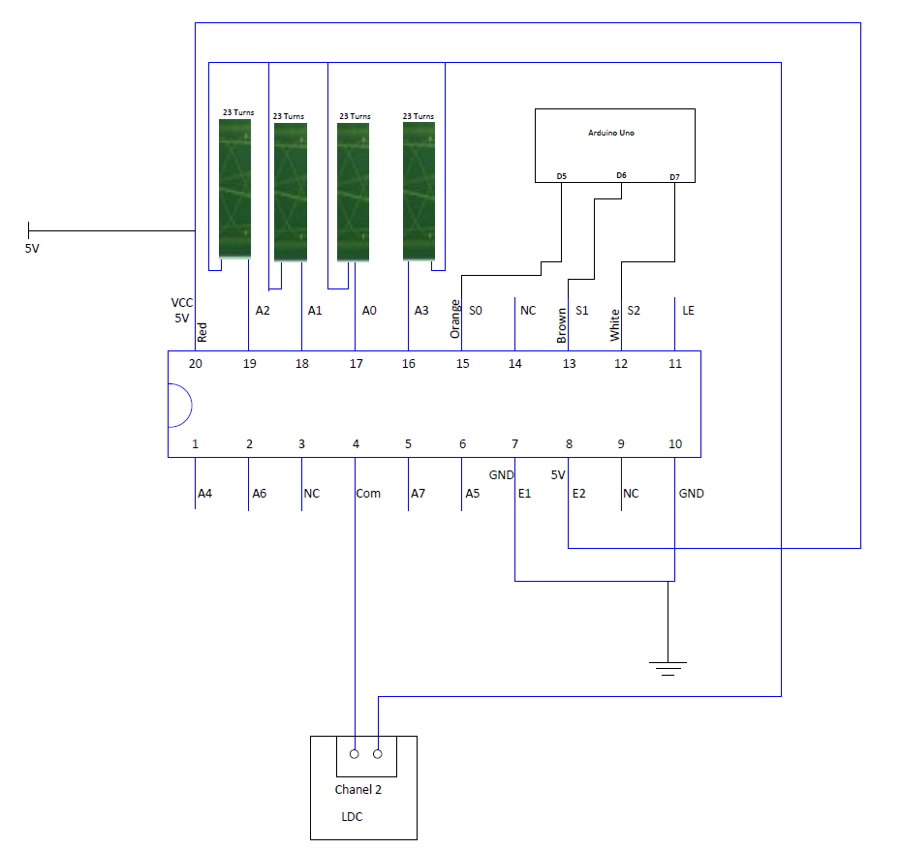

Figure 8: Schematic of Coils with MUX

Several weeks were dedicated in the month of November to correctly connect the data acquisition board to the arduino microcontroller. Initially the plan was to use a level shifter circuit to balance the voltage difference between the hardware. Eventually, two 4.7k ohm resistors were used to balance the 3.3V and 5V difference. These resistors were run across the SDA and SCL lines and knew it was successful because when all of the wires were connected the data stream was continuous in the Texas Instrument EVM Sensing GUI. All other pins from the LDC1614 can be grounded or left floating.

After the connection, the code for the arduino was written to extract the raw data from the LDC. Please refer to Figures 9,10, and 11 for the schematics and data readings.

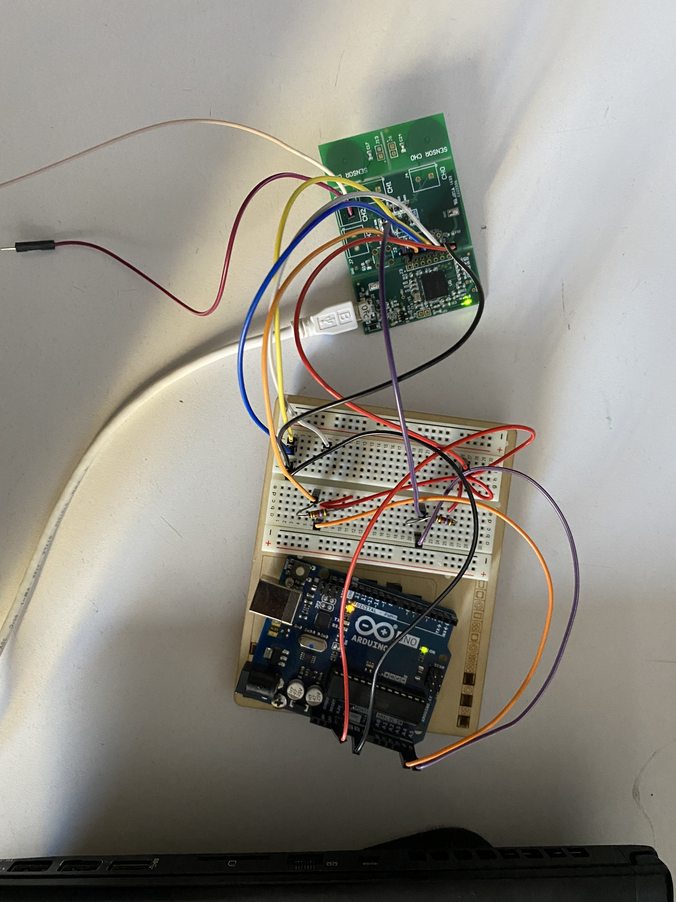

Figure 9: Connection between the LDC1614 and Arduino Uno

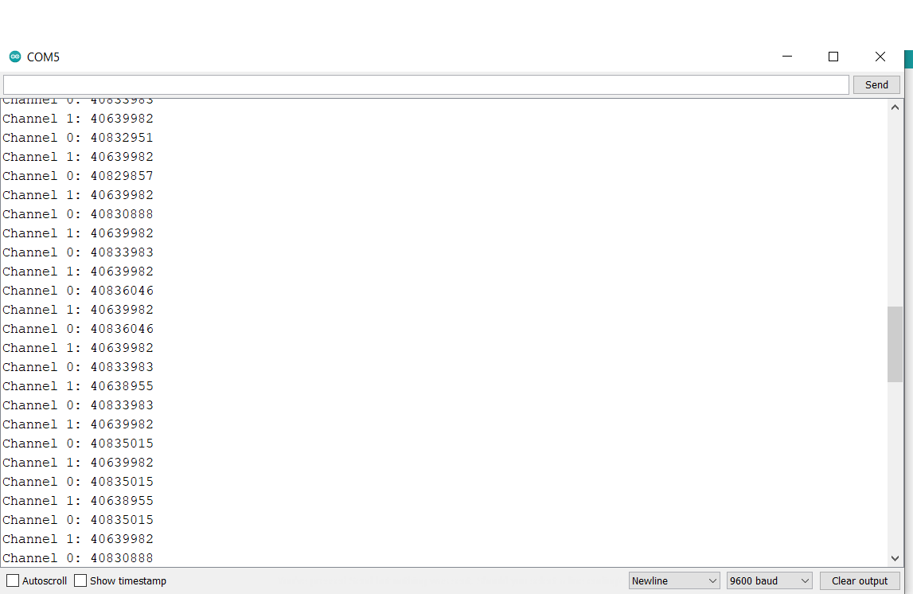

Figure 10: Arduino serial monitor displaying readings of raw data from LDC1614

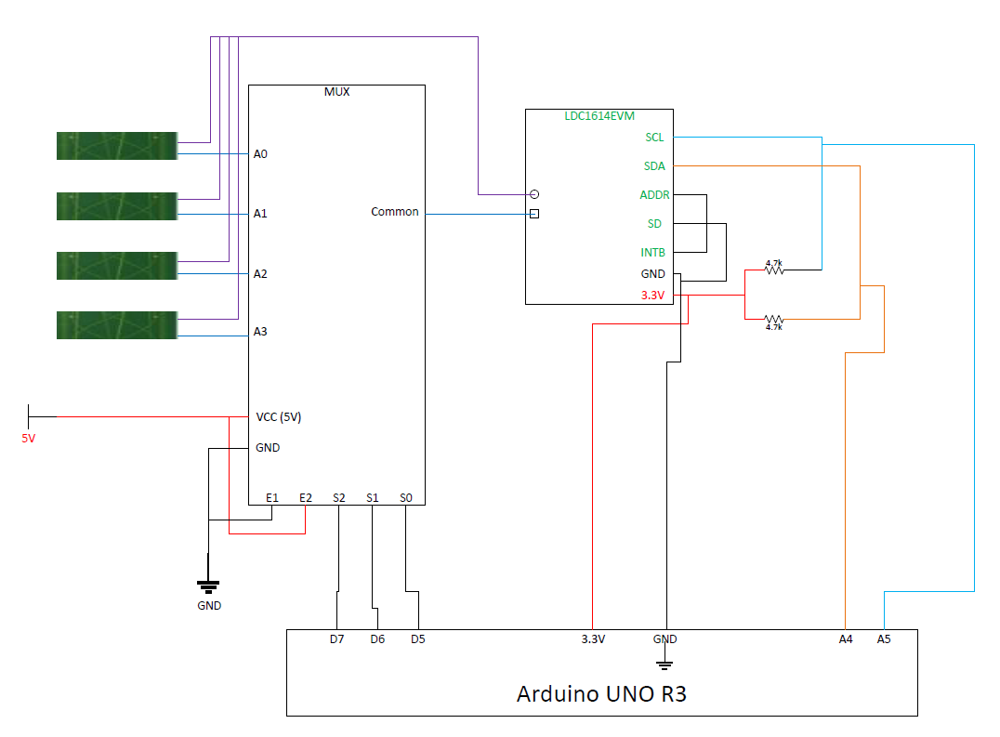

Figure 11: Schematic of the entire system including I2C connection and MUX

Figure 12 shows the proposed configuration that the inductive coils are currently placed in. As seen in figure 12, this is the best configuration to get the most accurate readings and distinct values in order for the machine learning algorithm to classify the hand gestures. Currently there are four inductive coils connected to the MUX, as seen in figure 12. When reading gestures the hand should remain stationary and respective to each of the fingers the coils were assigned to. To reduce the noise that was present in previous prototypes of the system, CAT6 ethernet wires were used for MUX to coil connections for secure readings. Figures 13 and 14, shows an experimental implementation of the coils used for gesture recognition. The MUX will switch between all four coils to recognize a gesture.

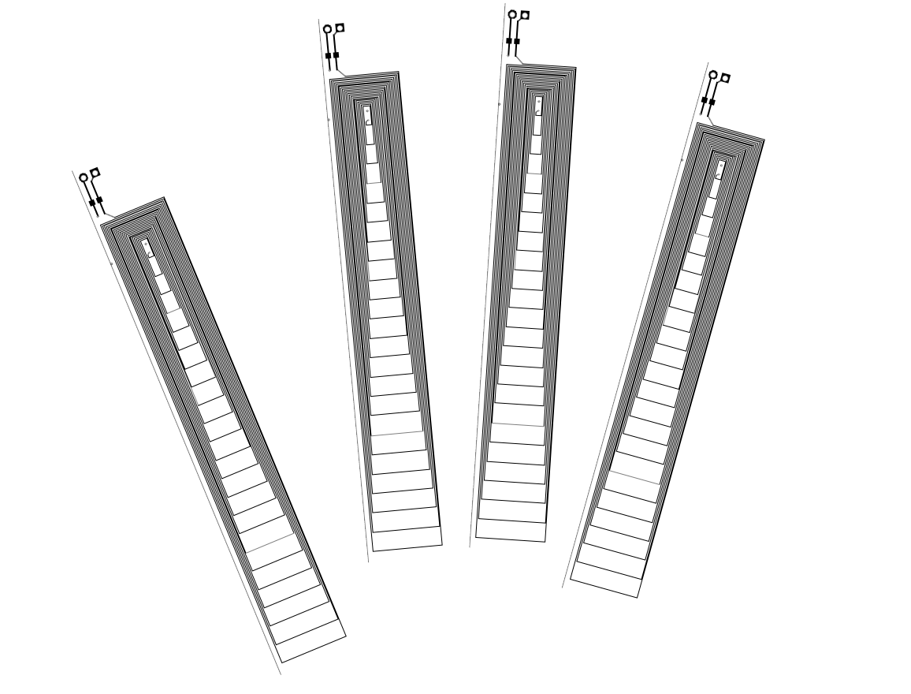

Figure 12: Bottom to top view of the proposed coil arrangement

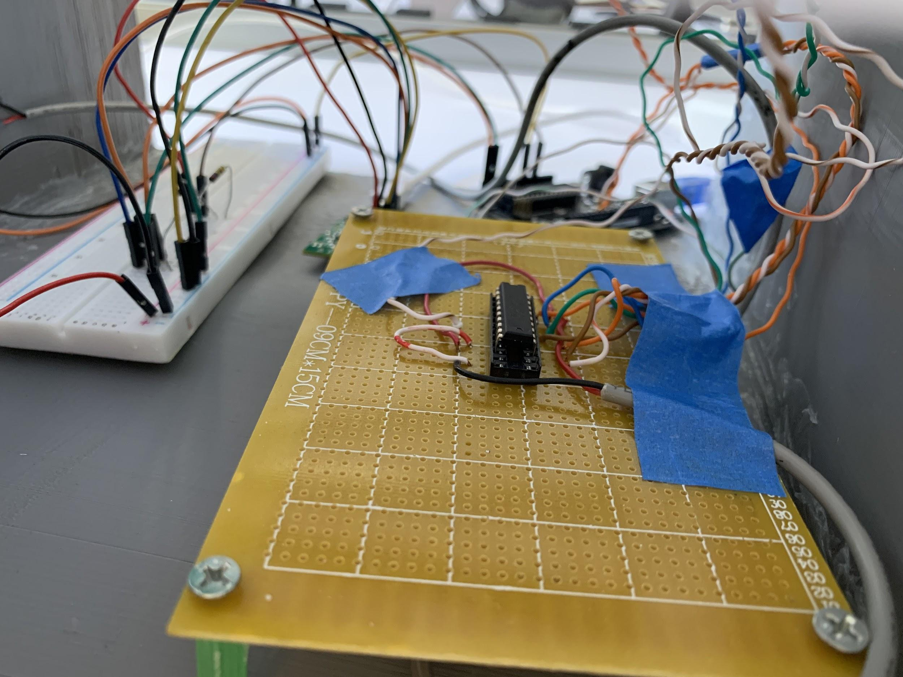

Figure 13: Current configuration of the array of inductive coils connected to the MUX

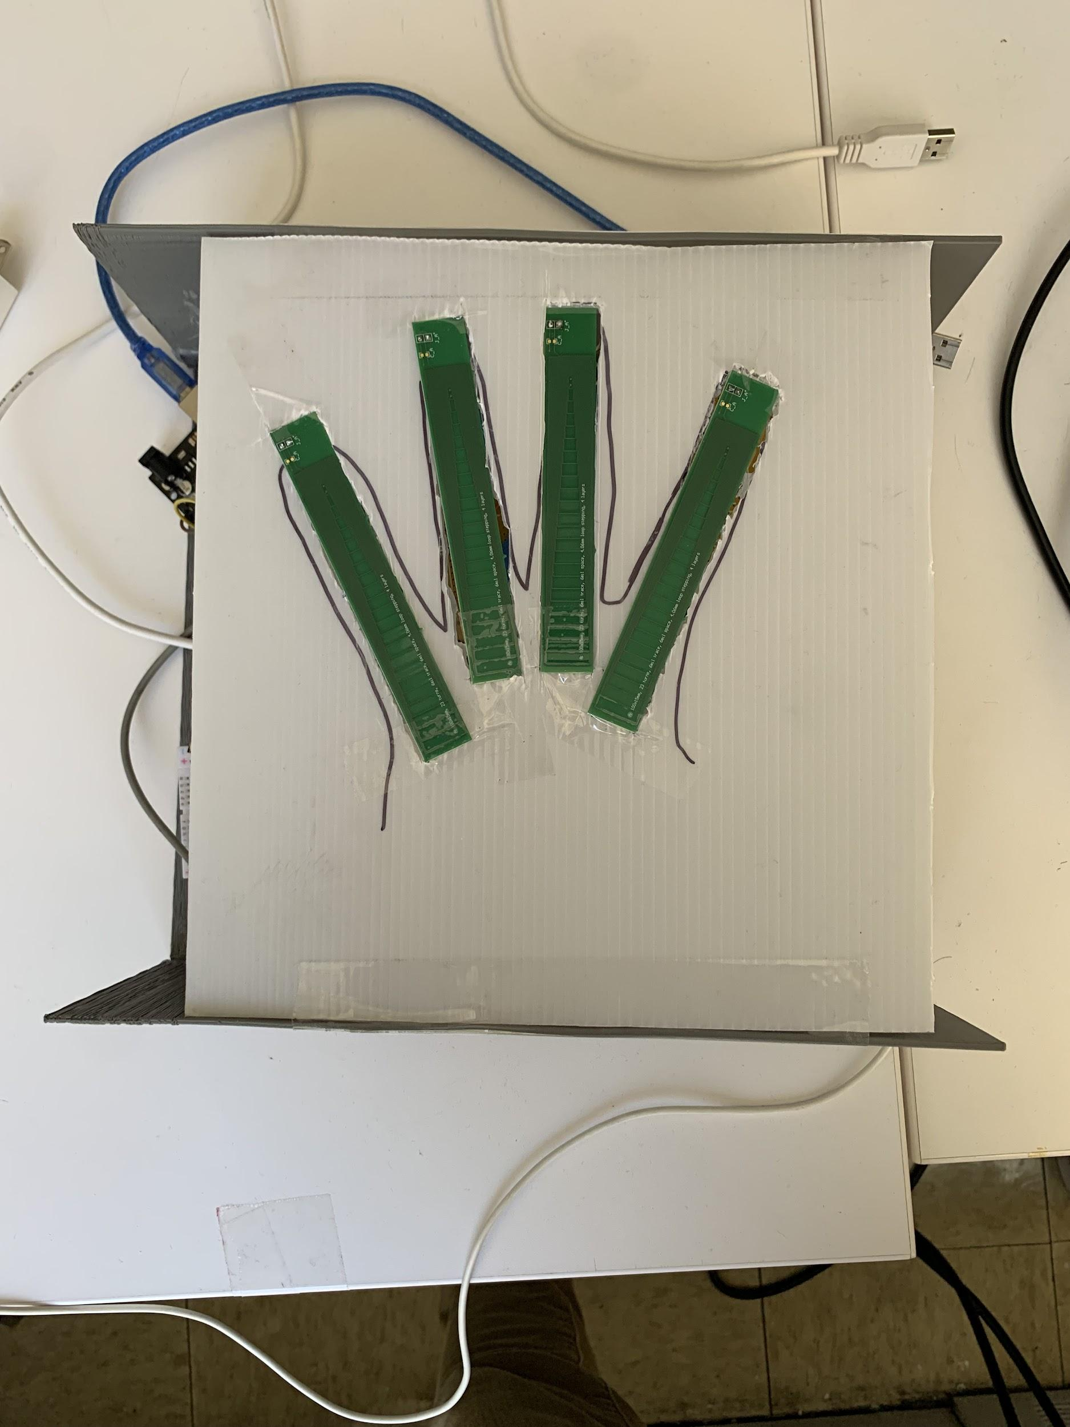

Figure 14: Current implementation of the arrangement of coils

Since a wheelchair is not in the budget of our project, an Arduino based RC car will be the substitute as seen in figure 15. This car was built in order to test the continuous hand gestures that will be implemented into the system. The car comes with four motors and a motor shield which is used to control both right motors and left motors. In the past, it was planned to have a bluetooth module connect the RC car to the PC such that the car’s motors can be controlled wirelessly from the PC. Due to time and budget restraints, the team decided to eliminate bluetooth communication between the system and the car, opting to simply use a wired USB connection.

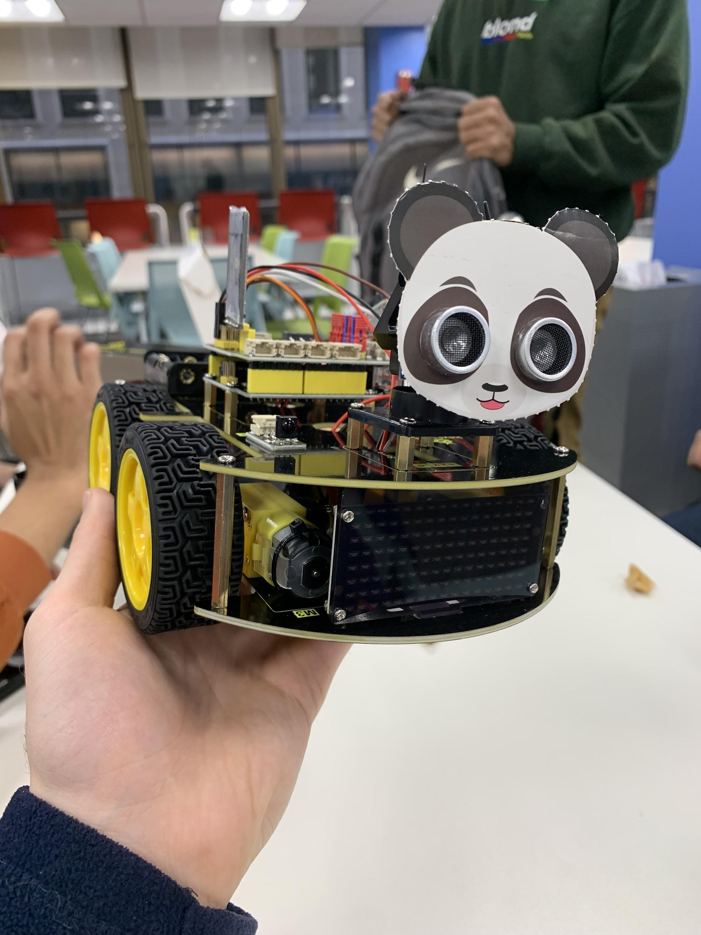

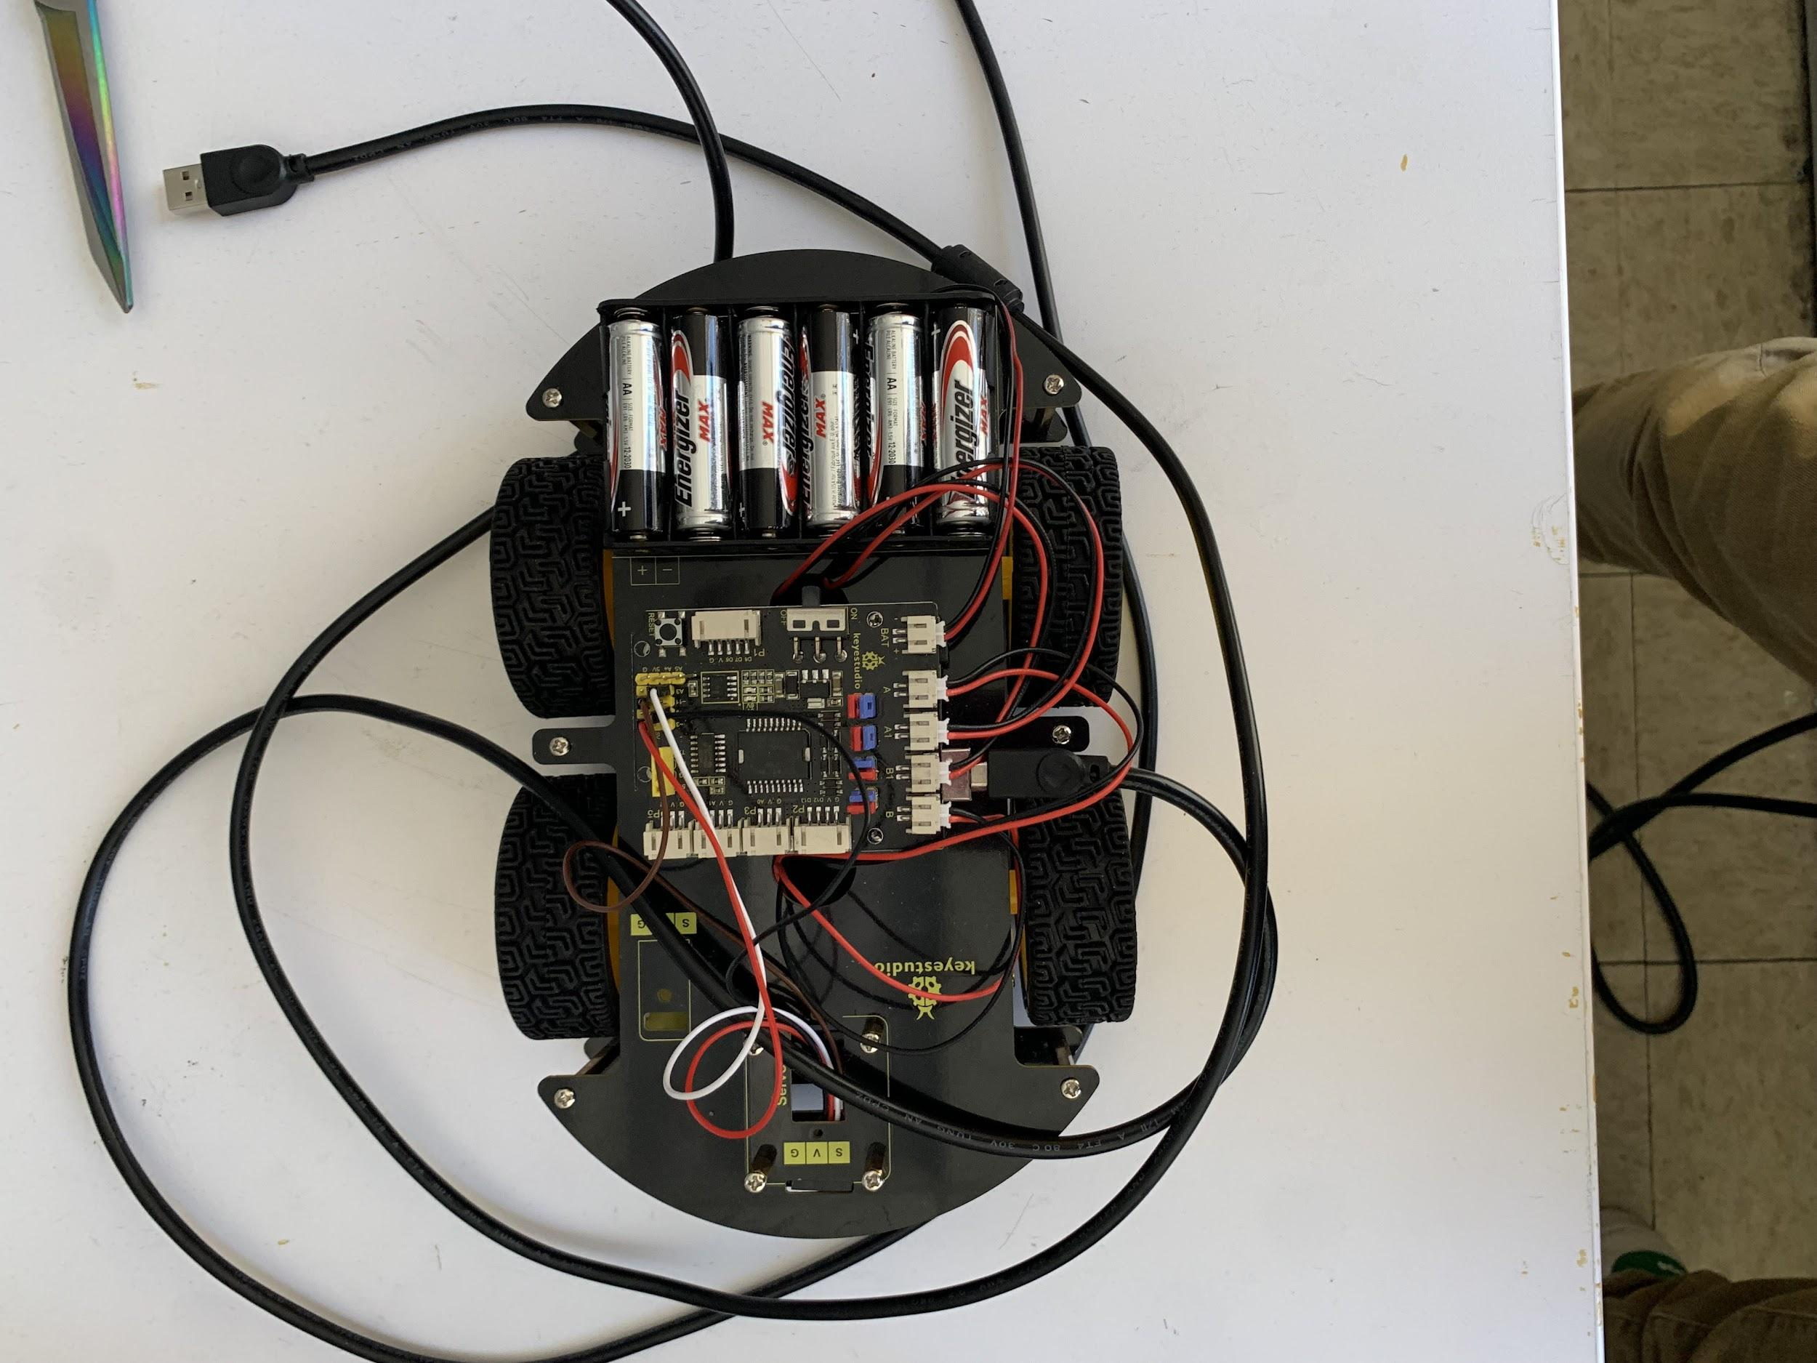

Figure 15: Arduino based RC car

## 3.3 Standards

The gesture recognition system that is used is based on I2C communication, which is a type of integrated circuit. I2C is a serial communication protocol in which data is transferred bit by bit along a singular wire. The arduino that is being used in this project is connected to the coils and forms an essential relationship that returns the necessary data from the changes in resonant frequency to Matlab. This allows for the KNN algorithm classification to be run properly.

## 

## 4 Commercialization

The next step in the near future for this project would be further innovation of this actual technology. The best possible outcome to improve this technology is through sponsored research support from either a university or preferably a company who deals in inductive sensing. This would allow the project to fully realize its potential in how far the device that is being developed can be pushed. This would approximately take about six months to fully realize what direction the technology can go and this is an ideal amount of time to do so. The ultimate goal would be to have a fully created prototype of inductive sensing for wheelchair movement so a patent can be established on the device and find a venture capitalist who would be in the technology industry and allow for commercialization of the product. The uncertainty in the technical aspect of commercializing this product would be the problem of people having different hands. A concern is that the system might encounter a person with a hand that isn’t recognized by the gesture recognition software such as a disformed hand. The uncertainty surrounding the marketing side of this design is the cost of the commercialization of the product and how much simplification can be done on the product to get the price of the device to be affordable for customers. A university that would be extremely helpful to connect with would be Georgia Tech. At their institution they are working on the aforementioned tongue controlled wheelchair through inductive sensing. There are similarities between theirs and the one being developed in this project. Cooperation between the two institutions would allow for further advancements in the understanding of the technology.

An important aspect of this project is the advantages this project brings to industry over other technologies. The two advantages this system exhibits is in privacy and in the availability of light. Depending on how accurate the system is, it will inform on how to implement this technology in the privacy space. In theory, the system can be trained to be individualized and differentiate between peoples hands with extreme accuracy. The other advantage this system has is that it does not need light or can work in no light. This is a big advantage to the technology of computer vision. Computer vision is a technology that is widely used for hand gestures. Recognizing hand gestures through inductive sensing is better than computer vision due to light being negligible.

## 5 Limitations and Further Development

By the end of this semester, the team was able to create a system which can recognize four hand gestures, excluding “No Gesture” which is when no hand gesture is being held to the coils. As discussed extensively in previous reports and presentations, the number of recognizable gestures is a direct result of the response recorded from the coils for this gesture is very similar to that of gesture 1. Another limitation currently in place is the ability to detect gestures in different locations and positions respective to the casing above the coils. In the current model, if the user would like to yield the best results, they would have to position their hand in a distance very close to the coils in order to have an accurate gesture classification. Once again, these nuances arise because of the close proximity of having four inductive coils arranged side by side. While the team was able to overcome the amount of noise or disturbance in the coil response compared to the results seen in this semester’s midterm report, there is still room for improvement in terms of minimizing noise in this system. Measures taken by the team this semester to combat this issue included using different wires and eliminating circular coils from the design.

Due to the overwhelming number of failures the team was experiencing with the system during the middle of the semester, after changing the wiring and entire circuit design, only two coils were implemented into the system and only two gestures were recorded. The team wanted to take the project one step at a time and verify that the system can properly perform with two gestures and then increase the amount of coils and gestures. Compared to the two coils and two gestures experimentation shown in the midterm, this time around it was extremely accurate. Two rectangular coils were used (the same ones from the final implementation) and the two gestures being used were simply one finger and two fingers held to the coils. As seen in Figure 16 , the system had a 95.6% accuracy in detecting either “one finger”, “two fingers”, or “no fingers”. This proved that our new hardware design improvements solved the problems experienced in the midterm presentation, so the team moved forward and then implemented the machine learning model into real time. This code was developed in MATLAB and when run, it read the data from the LDC, and then predicted the gesture being held to the coils, all in real time (all video results can be seen in the team’s website). Finally, after being able to predict gestures in real time, the final part of the project was to control the RC car in real time using these gestures. This code was also written in MATLAB and it connected the motor shield on the car to the arduino mounted on the car and based off of the gesture being predicted in real time by the machine learning model, the car would move forward for one finger, back for two fingers, and brake for no fingers.

After successfully implementing the entire system with two coils and two gestures, the team wished to push the limits of the system to implement four coils with four gestures. The final implementation of the four coil system can be seen in Figure 14. Exactly 100 data points were collected for each of the 4 gestures the system was being trained for. Similar to what was done earlier in the semester, this data was preprocessed into the form of a MATLAB table, with one column for the “Raw Data” and the other for the label of the gesture (see figure 17 ) . Once again the MATLAB machine learning toolbox was used to train several classification models and the highest accuracy was the fine gaussian SVM which was close to 71% as shown in Figure 19. The response of the finalized system can be seen in Figure 18, where each gesture’s data is recorded. The four coils individually switch after one second, in total the four coils cycle approximately every four seconds. As the team quickly noticed, specifically the system was having trouble distinguishing between Gesture 3 and the other gestures because the data recorded for Gesture 3 was very similar to other gestures, especially Gesture 1 and Gesture 4. In order to differentiate the data for Gesture 4 and Gesture 3, the fingers for Gesture 4 were placed in close proximity to the coils, to the point of contact. This, along with four fingers being in close range with the other coils caused the raw data value to generate readings in the range of 1.4 x10^7 instead of the usual range of 1.5 x 10^7 to 1.65 x 10^7 that the other gestures have. For this reason, in figure 18 it can be seen that gesture 4’s readings are extremely different from the other three gestures. Note that for Gesture 4 the large spikes are caused because of noise. Please note for Figure 18: the y-axis of this figure represents the raw data from the LDC 1614. As discussed extensively in previous reports, presentations and final presentation, the LDC is an inductance to digital converter which measures the oscillation frequencies of multiple LC resonators. The LDC 1614 outputs a digital value that is proportional to the frequency with 28 bits of resolution. Please refer to the LDC 1614 manual for all equations to do any conversions pertaining to measurements made by the data acquisition board. For the purpose of this experiment and project, the raw data recorded is sufficient to show the change in frequency as gestures are held up to the coils, as the two are proportional. The team used the TI GUI to look at raw data, frequency, and inductance of the coils, however, the raw data is what will be read in real time, therefore, the team believes it is appropriate to include here. Raw data is defined as the digitized sensor measurement for each channel; the register DATAx (x is 2 in this system because the team is using channel 2 of the LDC) represents the ratio of the sensor frequency to the reference frequency. Refer to section 8.1.3 of the LDC 1614 manual for supplementary tables and equations. To reiterate, the multiplexer in our system is switching between the four coils, each active for 1 second. This graph represents the readings from all four coils while they are switching at a rate of 1 second per coil. It is not possible to record separate readings between each coil because of the architecture of our system. The arduino is reading data from one channel of the LDC 1614 because all of the coils are connected via a common to a single channel on the LDC. Nonetheless, having results for a singular coil is elementary, as the entire goal of this project is to maximize the number of coils and see the results of the entire system while having multiple coils implemented.

For this system we were limited to using four gestures due to the configuration of the coils. Please refer to figures 20-23 for the hand gestures that were used in relation to the coils. For further development of the system it is recommended to use the other channels of LDC to fully utilize more coil and gestures. Due to the LDC input deglitch filter and saturation problem using different coils of different frequencies causes many issues to the system. By configuring each channel to handle different coils of different frequencies a more complex system can be achieved with higher accuracy rates and more distinct figures to categorize as gestures.

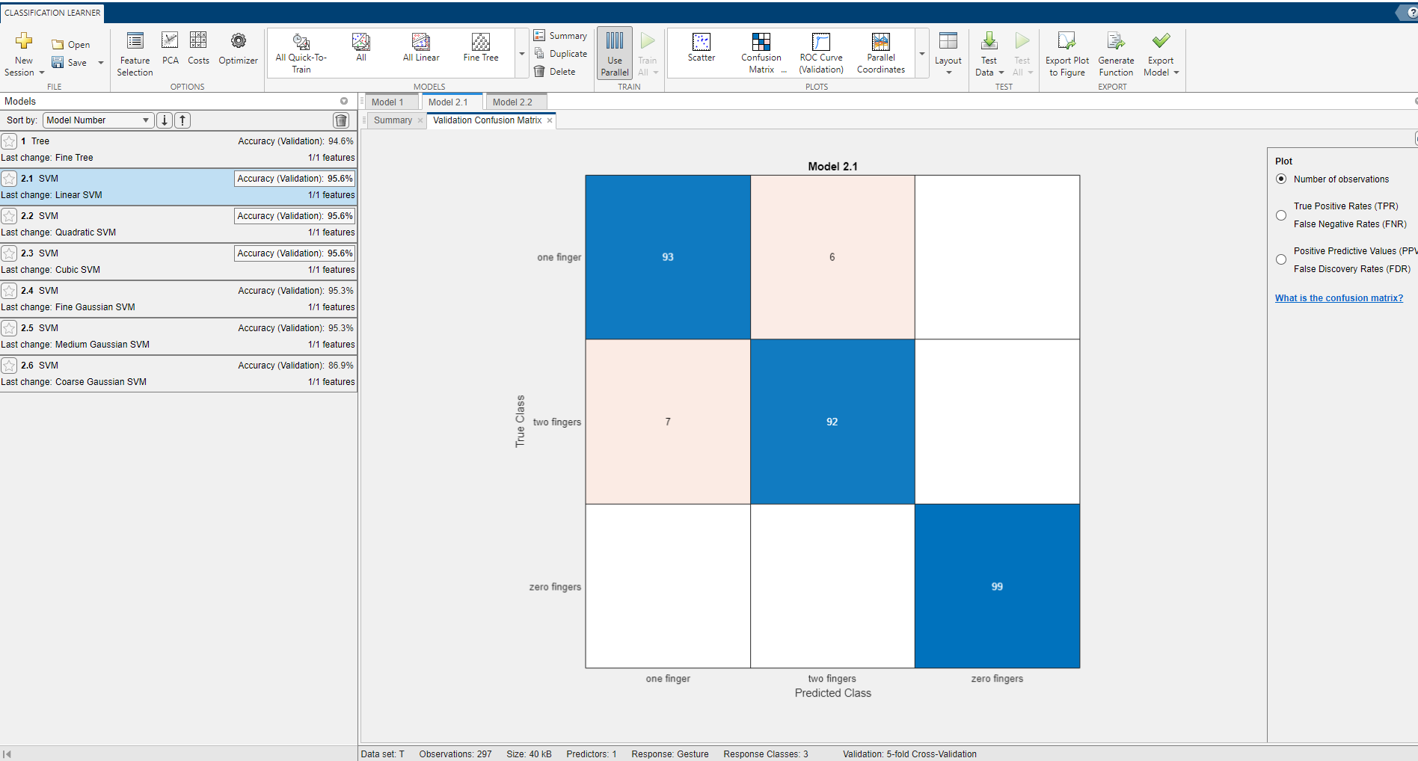

Figure 16: Confusion matrix for linear SVM algorithm (trained for two gestures)

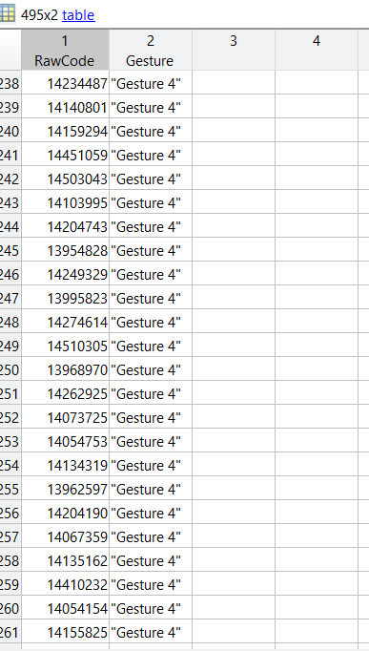

Figure 17: Sample of the dataset

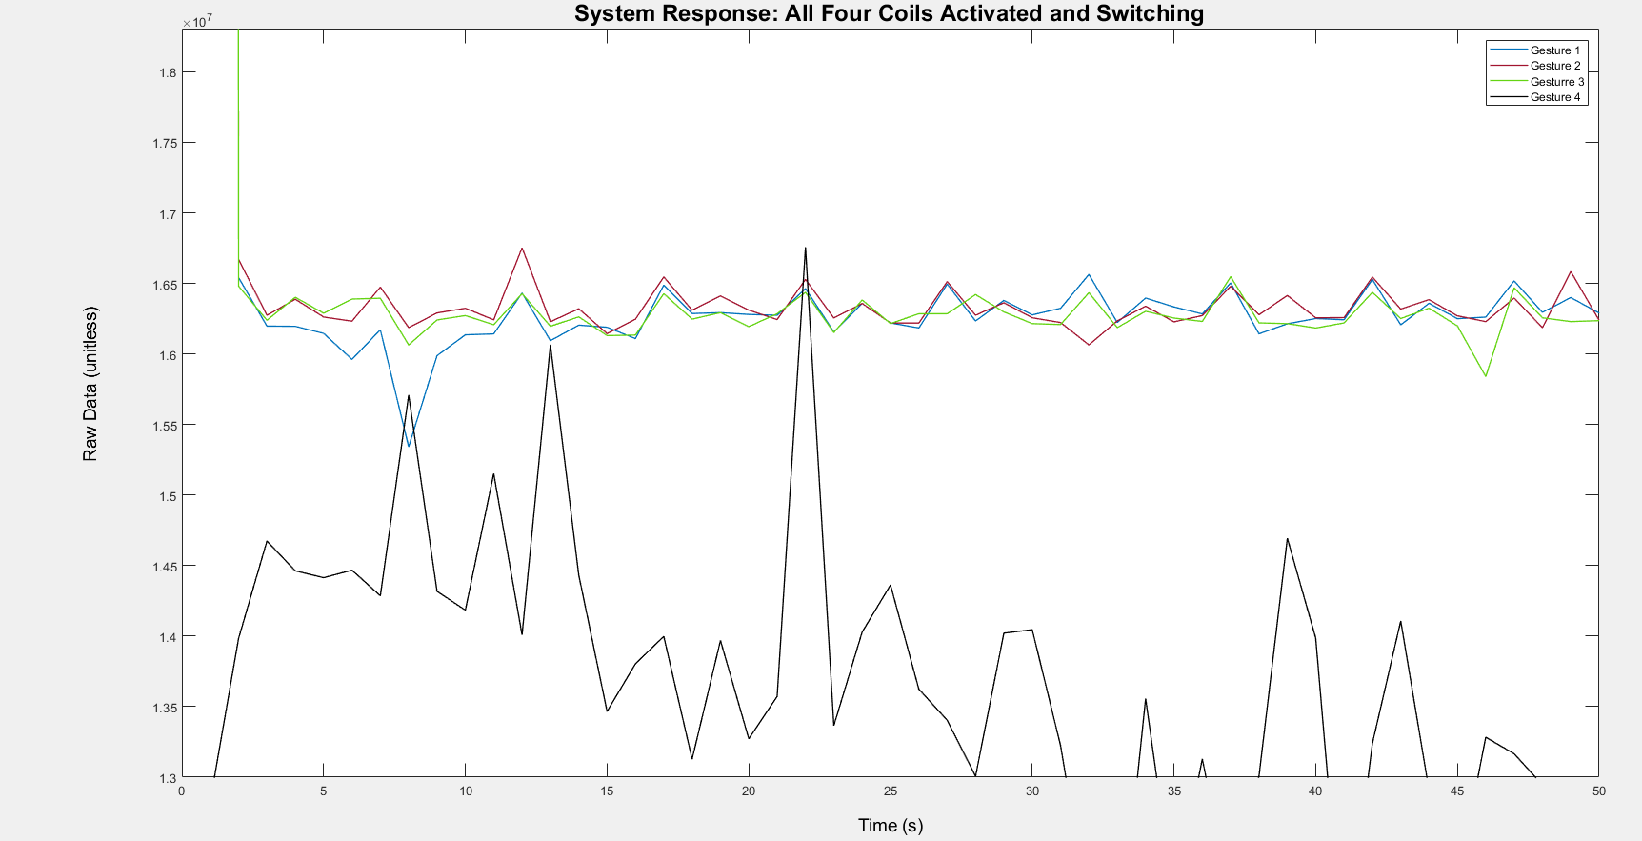

Figure 18 : System response of all four coils (data is read from one coil per second).

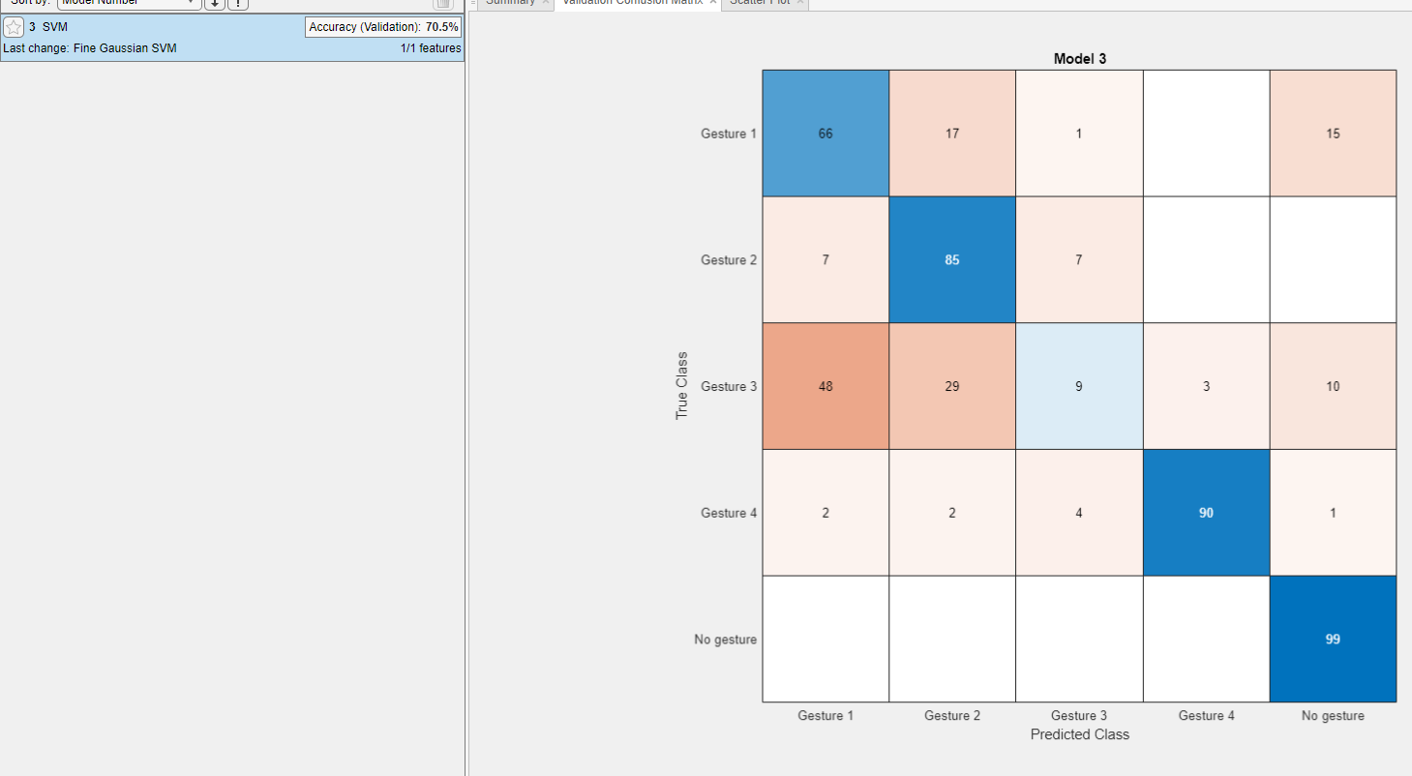

Figure 19: Machine learning results for four gestures

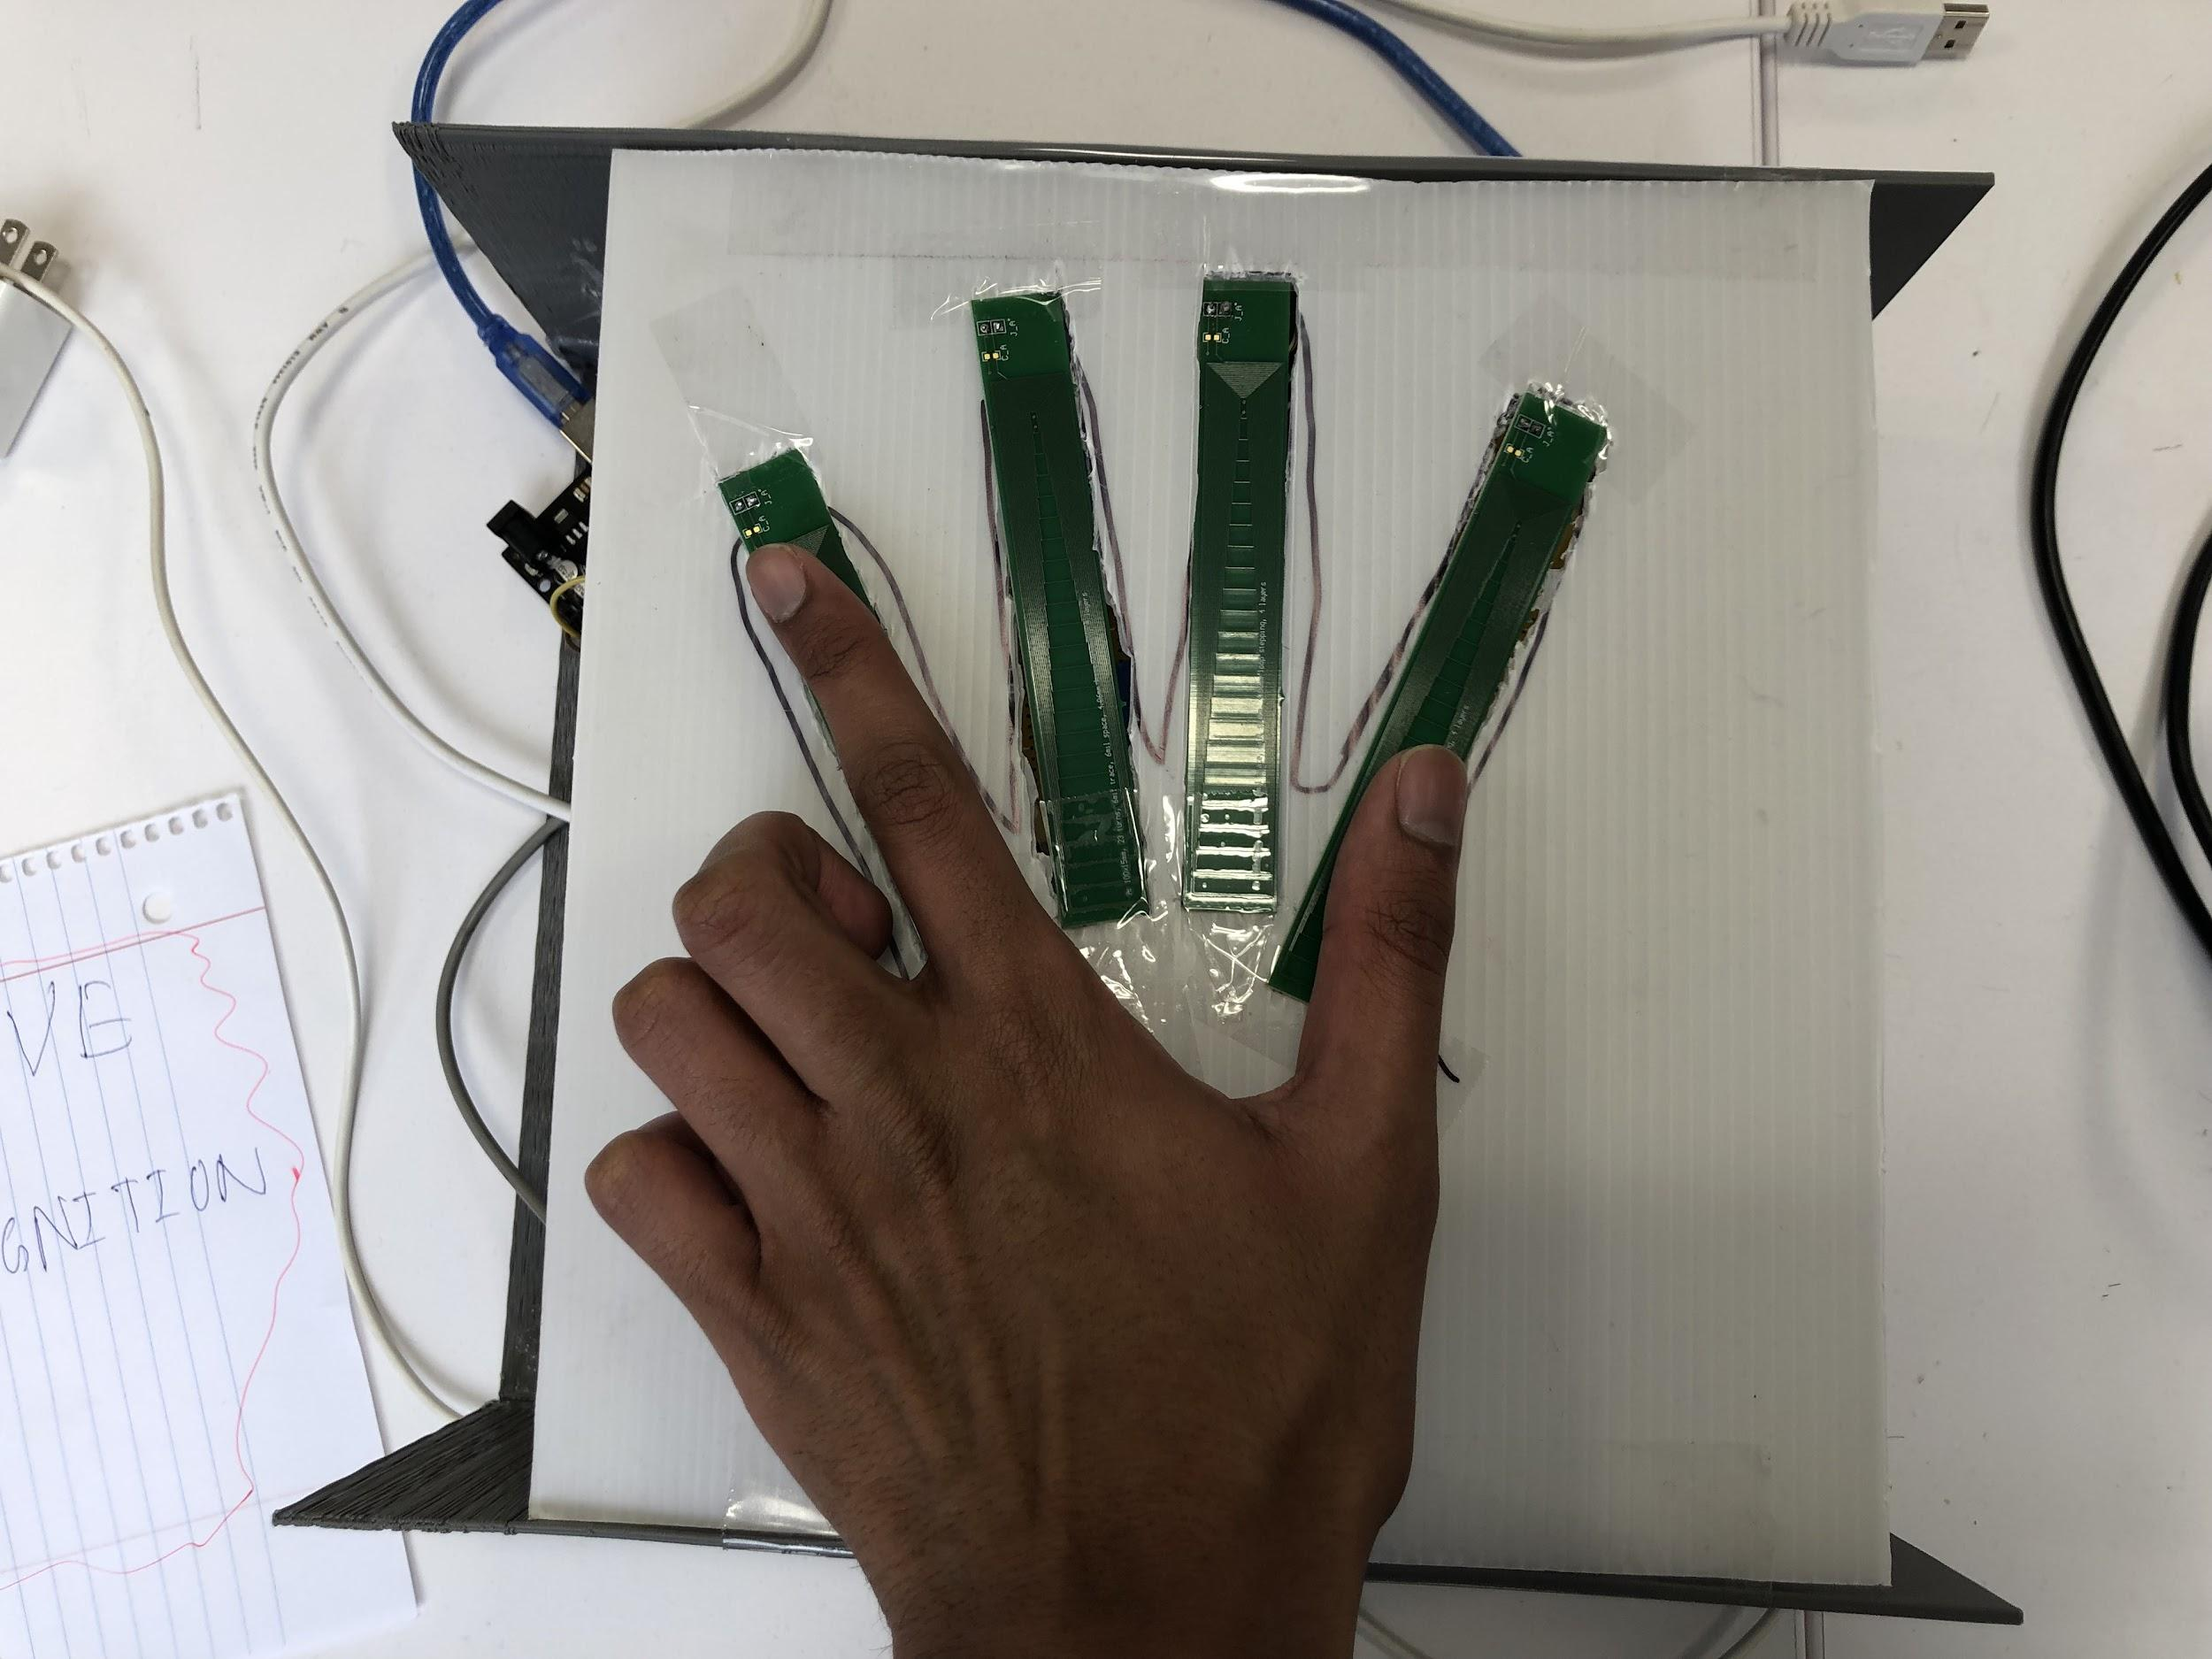

Figure 20 : Gesture 1

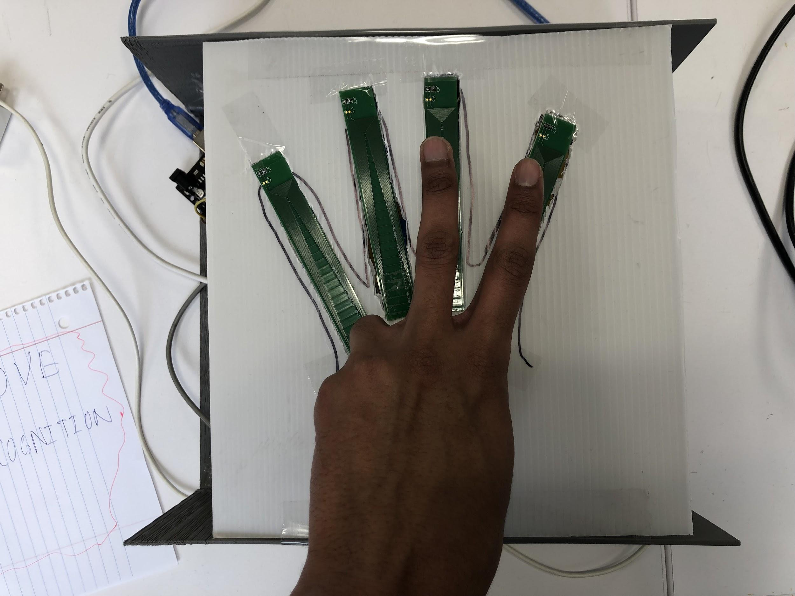

Figure 21 : Gesture 2

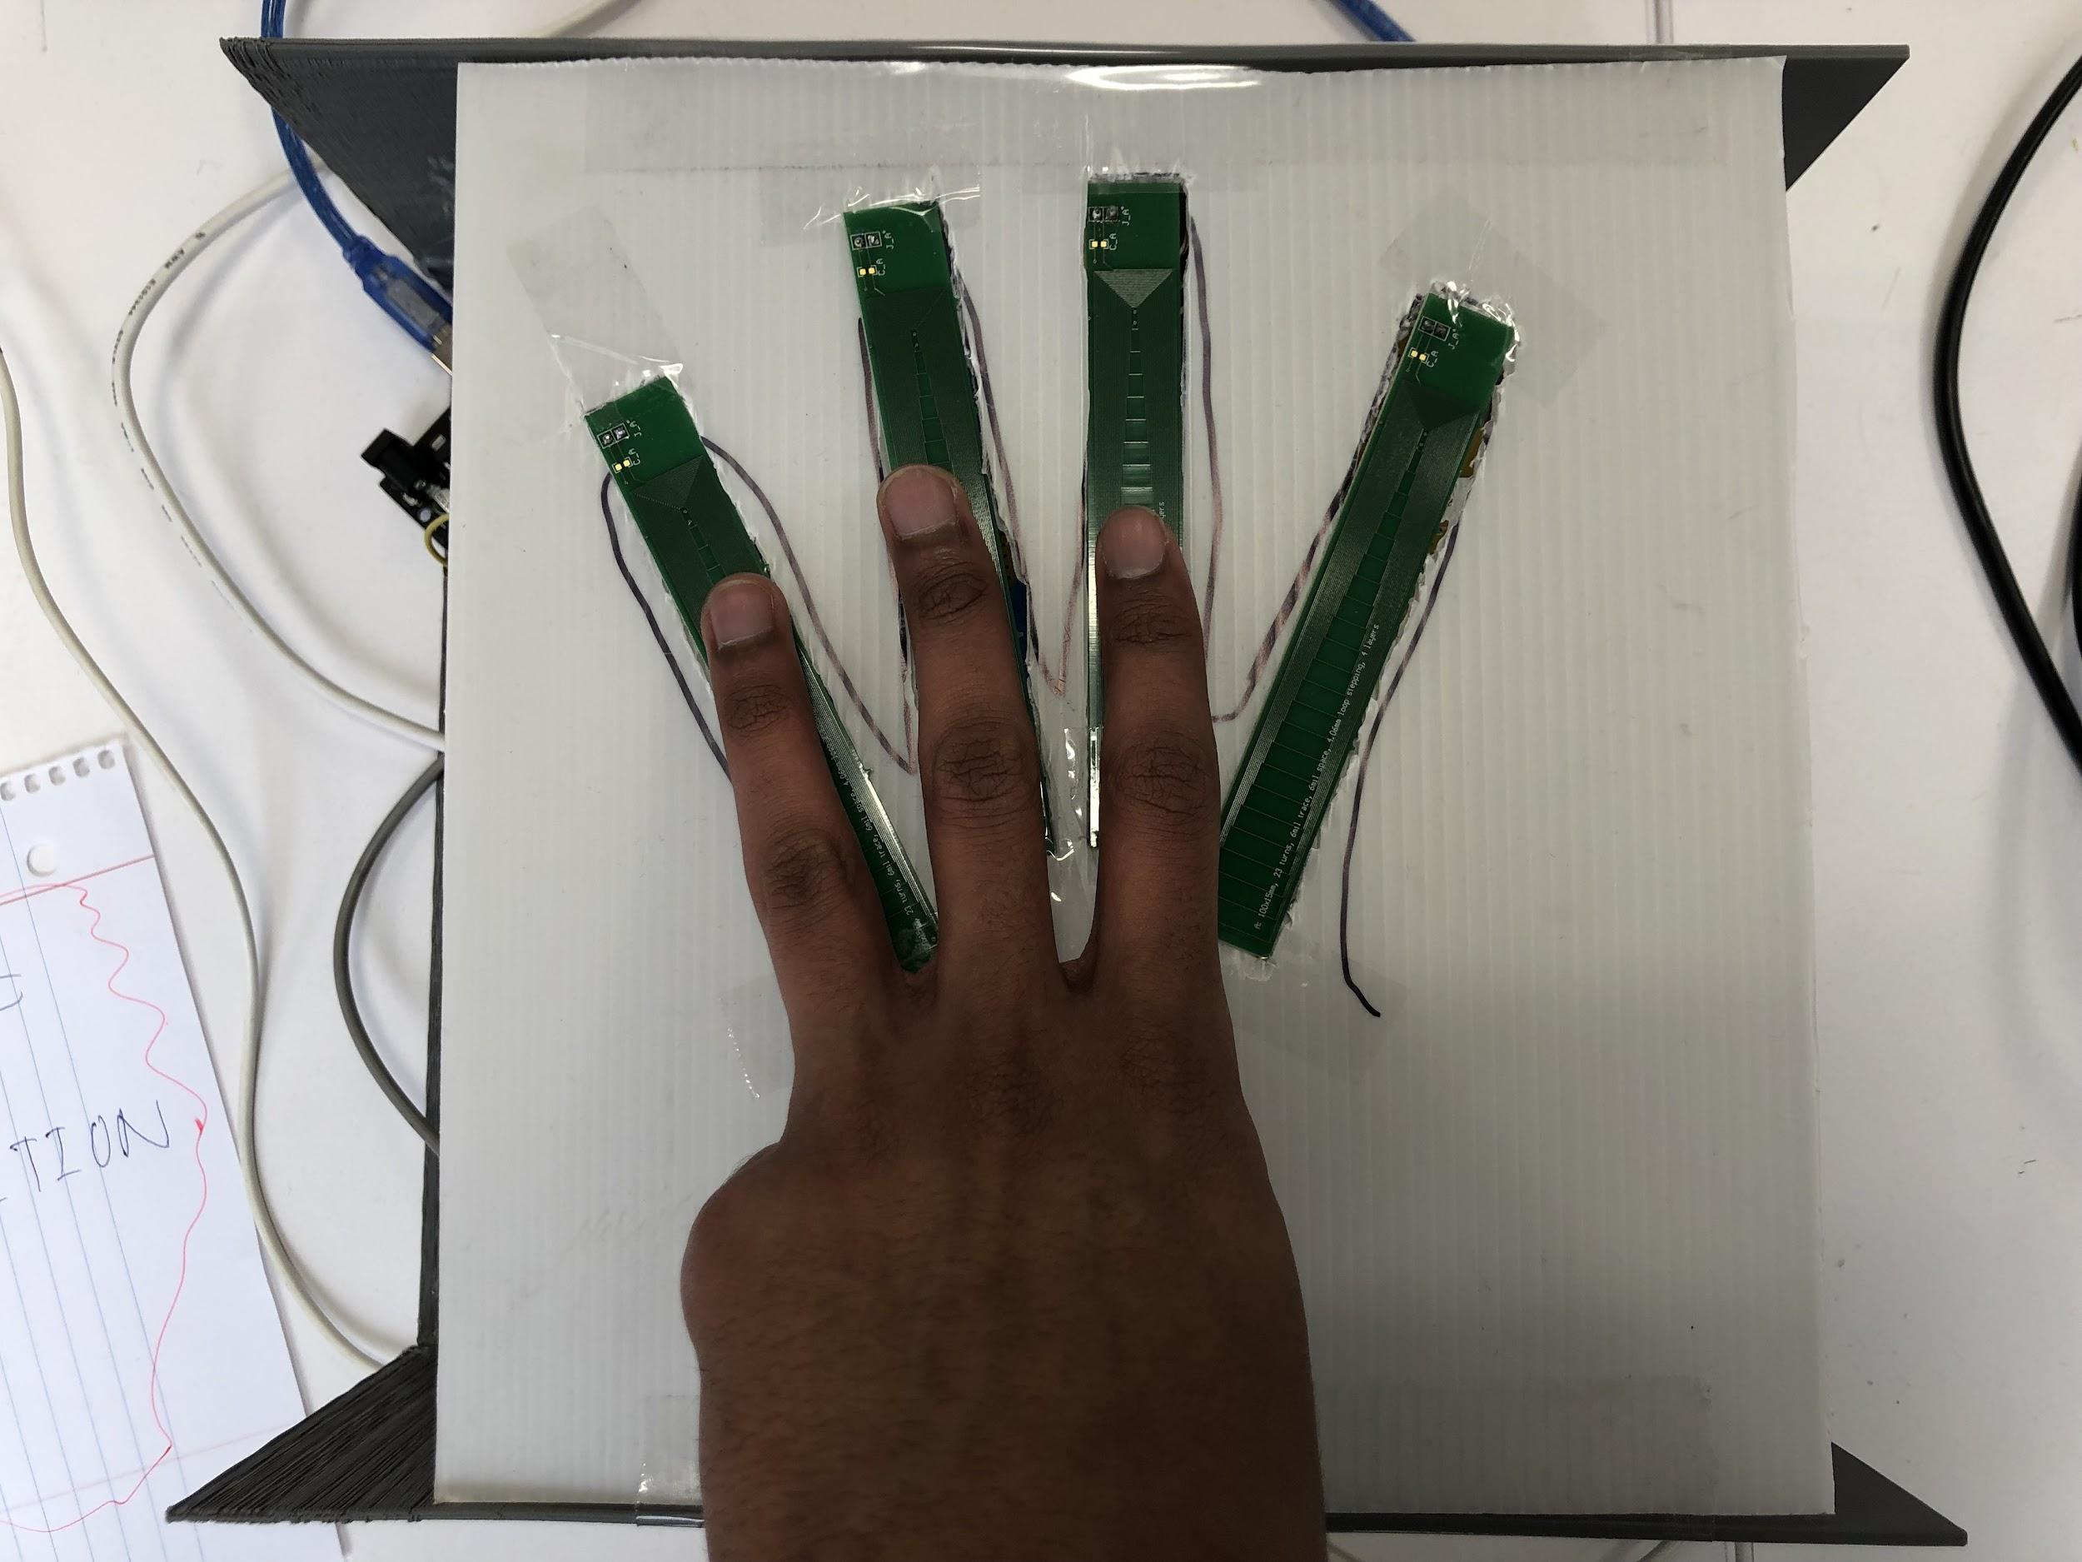

Figure 22: Gesture 3

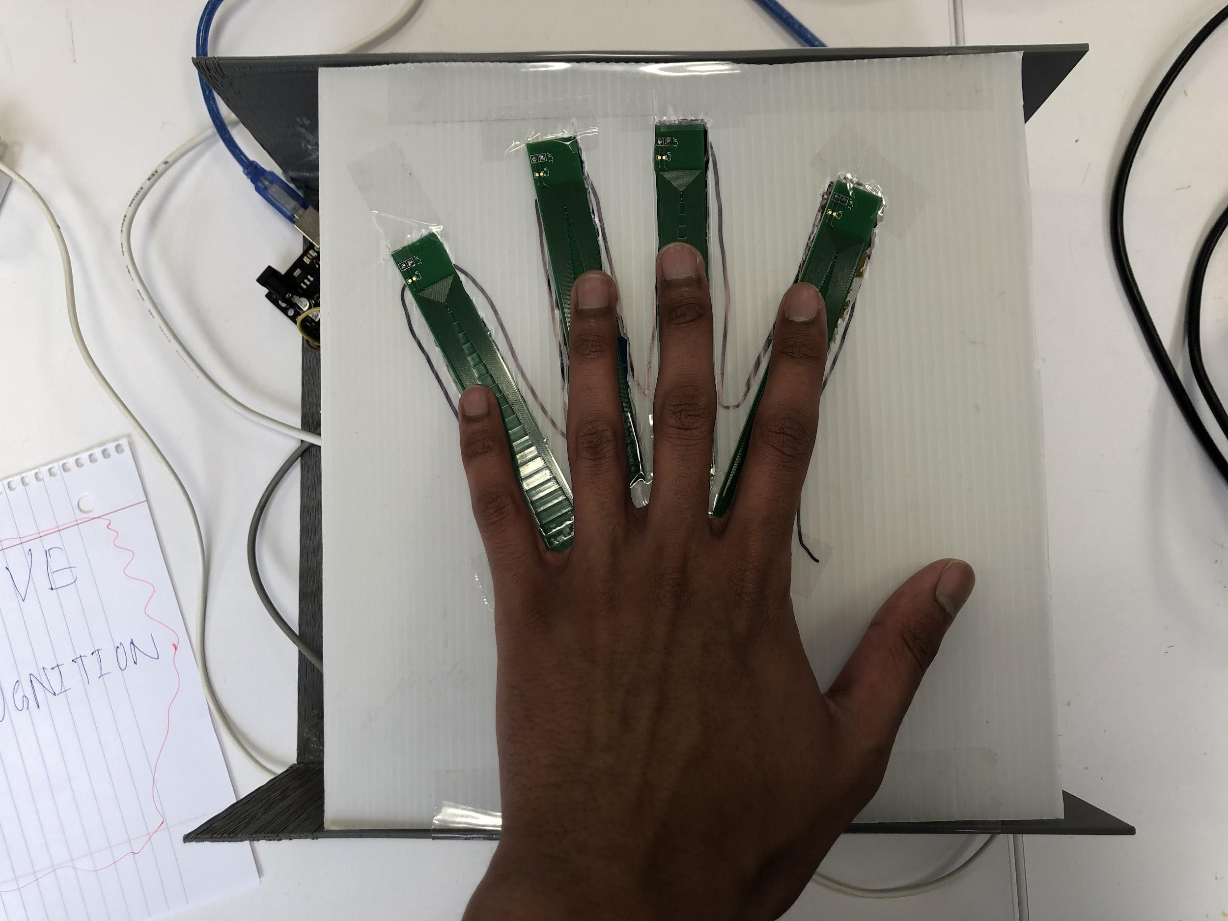

Figure 23: Gesture 4

## 5.1 Impact

This gesture recognition system can potentially have a large impact in both rehabilitation for disabled patients and also by displaying the strengths of inductive sensing. By using a wheelchair as the controlled vehicle for the gesture recognition device, if successful this technology can be extremely helpful for those with injuries or disabilities which restrict their gait. Also, considering the increase in hesitancy to interact with or touch surfaces as a result of the COVID-19 pandemic, this design provides a touch free solution to minimize the fear of user’s bacterial/viral transmissions. Furthermore, inductive sensing is a technique which has rarely been used in such applications, meaning our project can influence many other engineers in the future to build off of our work and extend the implementation of the gesture recognition system.

## 5.2 Prior Art

This project is completely unique and is not a direct extension of any other works. As mentioned previously, inductive sensing is an emerging technology and our use of this sensing to detect hand gestures is novel, to our understanding. This project, however, utilizes previous works that implemented other techniques such as capacitive sensing as a loose framework for the design. These systems used capacitive sensing and wearable devices, while this project is using coils and eliminating the use of wearable devices. These works are helpful when making decisions about the training of the machine learning model because they are training data in the same way that is desired for this project. An understanding of the prior research in the field will help build a system that learns from their mistakes and achieves greater accuracy.

## 6 Project Management Plan

## 6.1 Research Plan

The team’s main research plan was involved in multiple different stages. Concerning the hardware, the team leader was responsible for designing the configuration of the four coils in the casing. This was mainly done by consulting the LDC1614 manual and the properties of each different coil. The entire team initially contributed to literature review to familiarize with the existing technologies and research being done in the field. Using the information gathered, a decision was made to implement the K nearest neighbors algorithm initially, as other research suggests a very high accuracy in gesture recognition using KNN.

## 6.1.1 Inductive Coils - Aritra & Kevin

For this part of the project the Inductive Coils and LDC was researched in relation to the Texas Instruments LDCCOILEVM which was decided to be used for this project. Being a component of Texas Instruments, the coils would pair well with the LDC1614 and give off proper readings.

## 6.1.2 DAB & MUX - Aritra & Kevin & Patrick

For this part of the project research about connection from the coils and eventually to the Arduino was done which led to using LDC1614 which would take in the coil data from the MUX switching between the coils into a channel and give an output to be read by the Arduino.

## 6.1.3 Arduino and MATLAB - Patrick & Yousef & Dave

In the previous semesters, we have focused on establishing a hardware and software connection between our components. In Senior Design I, much of the semester was spent connecting the LDC1614 to the arduino uno via I2C standards. This was accomplished by accessing previous groups' works, along with online resources from the TI forums. The team ended the last semester with the ability to read data from the two channels implemented onto the LDC1614 via the arduino IDE.

By the beginning of the spring semester, the team was ready to begin reading data into MATLAB as well as implementing our software to do so for the multiple coils we have decided to use. This was met with another problem the group did not expect - the previous connection between the arduino and LDC1614 was not working properly. This was solved within one week and then we continued on to implement this software to work with the multiple coils and multiplexing. Two to three weeks were dedicated to working on the arduino code to operate with our multiplexer and switch between inputs. Following this, the team worked on translating this data from the arduino into MATLAB and then we were able to begin recording data and performing experiments with the system.

The final results of this section of the project were the creation of multiple programs in the Arduino IDE and MATLAB to extract data, run machine learning classification in real time, and also control the DC motors.

## 6.2 Team and Collaboration

## 6.2.1 Profile Team Leader Aritra Apon

The team leader is responsible for delegating responsibilities to the entire team and being aware of all actions being taken place within the team. He is also responsible for the hardware of the project and has done so with the setup of the coils, MUX and connection to the DAB with help from team members Patrick and Kevin. Most recently, he was able to contribute to the programming of the arduino digital pins to control the switching mechanism of the system to cycle through the coils being used.

## 6.2.2 Profile Team Member Dave Persaud

This team member is responsible for the machine learning and programming side of our project along with the interfacing between the microcontroller and the DAB. He had established which software the project will be using and the type of feedback and data we would be receiving. He has helped with the interface between the arduino and LDC, and has been able to extract data from the data acquisition board. Most recently, he was able to contribute to the programming of the arduino digital pins to control the switching mechanism of the system to cycle through the coils being used. He was also able to establish the communication between the arduino IDE and the MATLAB environment in order to record data for machine learning training.

## 6.2.3 Profile Team Member Patrick Mazza

This team member is responsible for the connection between hardware and software for our project so he works on connection from the MUX and DAB onto the arduino which connects to the computer. This team member is also working on the implementation of the Machine learning algorithm to the system.

## 6.2.4 Profile Team Member Kevin Gay

This team member is also responsible for hardware and should collaborate with team member Patrick as well with information regarding the MUX and DAB and organization onto the casing of the project. Also collaboration with team member Aritra regarding the coils and their placement onto the casing of the project. In the future his tasks will concern the mechanical design of the project.

## 6.2.5 Profile Team Member Yousef Ahmed

This team member will be responsible for the programming/software development of this project. Design for the machine learning model which will be the KNN classification will be done using Matlab programming language. Python programming language might be used too if it’s needed to do so.

## 6.3 Timeline & Milestones

For the first semester all research was done for the project and most materials were collected to start building the system. It was confirmed which algorithm was going to be used for predicting the gestures. All electrical components were decided as the coils were going to be connected to an MUX on a PCB board connecting to the LDC. Finally a casing was being developed to house all the electronic components. As shown in figure 24, the estimated timeline for this project. Below please find a description of each of the tasks listed on the gantt chart.

## 

Figure 24: Gantt Chart displaying the timeline of our project for EENG-489

For the second semester the prototype system was in development where a secure PCB board was built to house the MUX connecting the coils and LDC using CAT6 ethernet wires for secure and noiseless signals. In the end a fully functional prototype was developed where the system recognized four gestures and made an RC car move in four unique directions. All electrical components were protected by a case. As shown in figure 25, the estimated timeline for this project. Below please find a description of each of the tasks listed on the gantt chart.

## 

Figure 25: Gantt Chart displaying the timeline of our project for EENG-491

## 

## 

## 

## 7 Resources and Budget

For the project's budget, it was ensured that all the components and items bought for the system were from a reliable provider. The LDC1614 board and its components such as the coils and MUX were bought from Texas Instruments. The Arduino was purchased through Arduino Official. The robot car is bought from Keyestudio, providing a quantity of materials with a reasonable price. Please refer to figure 26 for the budget table, where the item, provider, quantity, price per unit, and justification are all provided. The total budget for this stays in range for the budget provided by the senior design course.

| **ITEM** | **PROVIDER** | **QUANTITY** | **PRICE PER UNIT** | **JUSTIFICATION** |
| --- | --- | --- | --- | --- |
| Arduino Uno R3 | Arduino Official | 1 | $23.00 | Arduino will be used as the microcontroller, collecting data from the LDC |
| LDC1614 EVM | Texas Instrument | 1 | $99.00 | The data acquisition board (DAB), used to collect analog data from inductive coils and convert to digital |
| LDCCOILEVM Development Kit | Texas Instrument | 1 | $30.00 | Array of inductive coils that will be used in the project |
| CD74HCT4351E | Texas Instrument | 1 | $0.75 | 8:1 MUX to connect the array coils to one channel |
| KEYESTUDIO Smart Car Robot,4WD Programmable DIY Starter Kit for Arduino for Uno R3 | KEYESTUDIO | 1 | $70.00 | Will be used to carry out gesture commands. 4WD with four motors and motor shield included. Along with a bluetooth module for communication. |
| **Total Price:** | $222.75 | | | |

Figure 26: Budget table

## References

1. LDC1612, LDC1614 Multi-Channel 28-Bit Inductance to Digital Converter (LDC) for Inductive Sensing. Available at:

<https://www.ti.com/lit/ds/symlink/ldc1612.pdf>

# I2C bi-directional level shifter. Available at:

[https://playground.arduino.cc/Main/I2CBi-directionalLevelShifter](https://playground.arduino.cc/Main/I2CBi-directionalLevelShifter/)

# Gesture Recognition and Touchless Sensing Market worth $37.6 billion by 2026 - Exclusive Report by MarketsandMarkets. Available at:

<https://finance.yahoo.com/news/gesture-recognition-touchless-sensing-market-13300092>

1. LDC Reference Coils User’s Guide. Available at:

[https://www.ti.com/lit/ug/snou136/snou136.pdf](https://www.ti.com/lit/ug/snou136/snou136.pdf?t)

1. Sensor Design for Inductive Sensing Applications Using LDC. Available at:

<https://www.ti.com/lit/an/snoa930c/snoa930c.pdf>

1. Data Sheet for CD74HCT4351E. Available at:  
   https://www.ti.com/lit/ds/symlink/cd74hct4351.pdf?ts=1647451349521&ref_url=https%253A%252F%252Fwww.ti.com%252Fstore%252Fti%252Fen%252Fp%252Fproduct%252F%253Fp%253DCD74HCT4351E

## Appendix

LDC 1614 Block Diagram

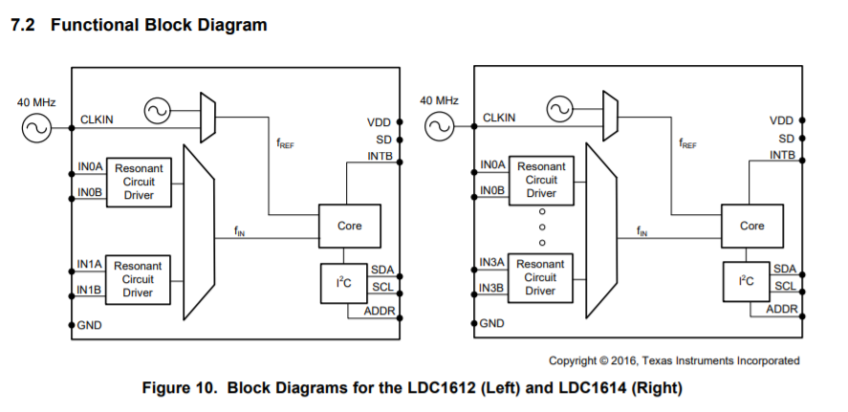

Table of Pin Functions (LDC 1614)

